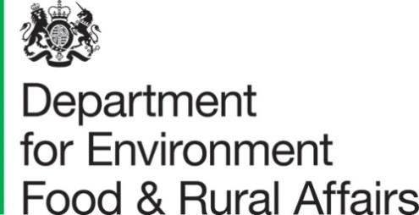 | Sand HuttonYork  YO41 1LZ | T:03459335577  helpline@defra.gov.ukwww.gov.uk/defra
Date:8November2023
To:IPPCcontactpoints

PhytosanitarydeclarationforBactrocera latifrons(Hendel)

I am writing regarding new legislation that has entered into force on 1 October 2023,whichwill apply to exports fromyourcountry.

ThechangesthelegislationmakestoourimportrequirementsforBactroceralatifrons(Hendel) requires an advanced declaration to be provided to facilitate trade. Pleasecould you complete the attached template and return it to uknppo@defra.gov.ukatyourearliest convenience.

Thankyouforyourcontinuedcooperation.

Yourssincerely,
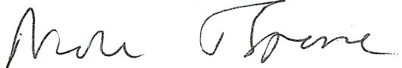

ProfessorNicolaSpence
UKChiefPlantHealthOfficer

Table1: PleaserefertoAnnex7 partAoftheretainedPhytosanitaryConditionsRegulation(2019/2072)whencompletingthistable

 |  |  | Bactroceralatifrons(Hendel)
 |  |  | 102B(a)–  countryfreedom | 102B (b) - pestfreeareas(PFAs)  - names of PFAsto beprovided | 102B(d) -  systems approach | 102B (d) - post-harvesttreatment | Date of latestcommunication /Review
102B | Fruitsof Capsicum | CapsicumL. | X
 | L. andSolanumL,
originatingin
Algeria,Angola,
 |  | SolanumL | X
 | Benin,Botswana,
 | BurkinaFaso,
 | Burundi,Cameroon,
 | CapeVerde,Central
 | AfricanRepublic,
 | Chad,Comoros,
 | Congo,Côte
 | d’Ivoire,Djibouti,
 | Egypt,Equatorial
 | Guinea,Eritrea,
 | Eswatini,Ethiopia,
 | Gabon,Gambia,
 | Ghana,Guinea,
 | GuineaBissau,
 | Kenya, Lesotho,
 | Liberia,Libya,
 | Madagascar,
 | Malawi,Mali,
 | Mauritania,
 | Mauritius,Mayotte,
 | Morocco,
 | Mozambique,
 | Namibia,Niger,
 | Nigeria,Réunion,

Rwanda, Sao Tomeand Principe,Senegal,Seychelles, SierraLeone, Somalia,South Africa, SouthSudan,Sudan,Tanzania, TheDemocraticRepublic oftheCongo,Togo,Tunisia, Uganda,Zambia, Zimbabwe,Afghanistan,Bahrain,Bangladesh,Bhutan, BruneiDarussalam,Cambodia, China,India, Indonesia,Iran, Iraq, Japan,Jordan, Kazakhstan,Kuwait, Kyrgyzstan,Laos, Lebanon,Malaysia, Maldives,Mongolia, Myanmar,Nepal, North Korea,Oman,Pakistan,Philippines, Qatar,Russia (only thefollowing parts: FarEastern FederalDistrict(Dalnevostochnyfederalnyokrug),
SiberianFederal

District (Sibirskyfederalnyokrug),and Ural FederalDistrict (Uralskyfederalnyokrug)),Saudi Arabia,Singapore, SouthKorea, Sri Lanka,Syria, Tajikistan,Thailand, Timor-Leste,Turkmenistan,United ArabEmirates,Uzbekistan,Vietnam, andYemen

