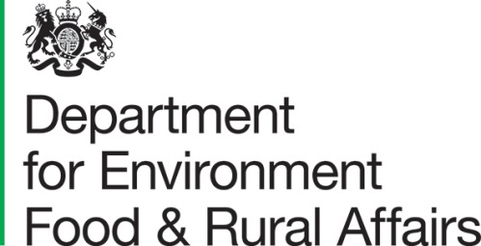 |  |  | York Biotech Campus  Sand Hutton  York  YO41 1LZ
 | Mr Bernard Van Goethem and Mr Sylvain Giraud  Crisis Preparedness in Food, Animals and Plants  Plant Health (SANTE G.1)  Froissart 101,  Rue Froissart 101 / Froissartstraat 101,  1000 Bruxelles / Brussel, PO Box 1049 |  | Date: 14 August 2026
Dear Bernard and Sylvain,

Comment on EU WTO SPS Notification G/SPS/N/EU/958

The United Kingdom welcomes the opportunity to comment on the measures in the European Union’s WTO SPS notification G/SPS/N/EU/958, concerning amendments to the Phytosanitary Conditions Regulation (EU) 2019/2072.

We welcome the European Union’s notified amendments to its Regulation to list Chrysobothris femorata sensu lato and Chrysobothris mali as EU Quarantine Pests.
However, the United Kingdom is concerned with the absence of measures on wood for all confirmed hosts of Chrysobothris femorata sensu lato.

Based on the recommendations of the European and Mediterranean Plant Protection Organisation (EPPO) Pest Risk Analysis (in section 16 of the EPPO PRA, see Annex for details), we suggest a revision to the proposed entries for Annex VII to include measures on wood for all confirmed hosts (category 1A) in the EPPO PRA, not just Juglans, of Chrysobothris femorata sensu lato. This is in accordance with EPPO advice which indicates this is necessary to mitigate the phytosanitary risk posed by long-distance spread via wood materials, which does not currently appear to be addressed by the proposed measures.

We would be grateful for the European Union’s positive consideration of this suggestion and stand ready to engage further on any technical matters.

Yours sincerely,



Professor Nicola Spence CBE
UK Chief Plant Health Officer
nicola.spence@defra.gov.uk
UKNPPO@defra.gov.uk

Annex - Risk management recommendations
The EPPO Panel recommended that:

- Host round wood should:
Be stored and transported in conditions preventing infestation.
And
come from a Pest Free Area.
Or
be subject to a heat treatment.
Or
be subject to irradiation.
Or
be subject to fumigation with sulfuryl fluoride (for debarked wood below 20cm in cross-section)

- Host sawn wood (>6mm) should:
Come from a Pest Free Area.
Or
be subject to a heat treatment.
Or
be subject to irradiation.
Or
be subject to fumigation with sulfuryl fluoride (for debarked wood below 20cm in cross-section)

