Department for Environment, Food and Rural Affairs

United Kingdom demarcated area report for Anoplophora glabripennis (Asian longhorn beetle); March 2013 – April 2014

Date: 17 June 2014

Author: Justin Dixon (Defra Policy)
Contributors: Dominic Eyre (Fera), Edward Birchall, Peter Scotting (Fera PHSI), Ian Brownlee (Forestry Commission).

Contents
Introduction 1
Scope of the report 1
Location of outbreak 1
Surveillance 1
Survey of sentinel trees 1
Local awareness campaign 2
Pheromone trapping 3
2013-2014 Winter survey 4
Tree climber survey 4
Next steps 6

Introduction
Anoplophora chinensis (Citrus longhorn beetle) and the closely related A. glabripennis (Asian longhorn beetle), are both Annex IAI listed pests in the EU Plant Health Directive 2000/29/EC. As a result they are organisms whose introduction, and spread within, all Member States (MS) is banned.
The EU have also introduced specific emergency measures for MS to implement for Anoplophora chinensis (Citrus longhorn beetle) to prevent its introduction and spread within the Union in the form of Commission Implementing Decision 2012/138/EU, hitherto referred to as the Decision. Specific EU emergency measures do not exist for A. glabripennis, however, given it is so closely related to A. chinensis both the Decision and the UK’s contingency plan for that pest also form the basis of the UK response to A. glabripennis.
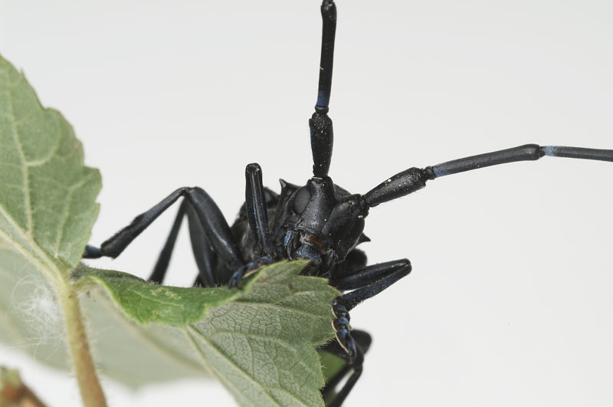

Scope of the report
This report sets out for the Commission and other MS the measures taken between April 2013 and March 2014 and future measures the UK intends to take within the demarcated area following the 2012 outbreak of A. glabripennis in Kent, South East England. This is the second year of surveillance following the last detection of the pest and completion of host removal at the outbreak site. The report does not include details on the detection of the outbreak, host removal and findings which were reported in the 2012-2013 report.

Location of outbreak
The outbreak detected in 2012 is in Kent in the south-east of England. It is approximately 2km north of the town of Paddock Wood and 50km south-east of the centre of London. Most of the infested trees were found in trees alongside a rural road, but some have also been found on a commercial property and some within domestic properties.

Surveillance
- April 2013 – survey of sentinel trees
- July 2013 – local awareness campaign (school presentations and householder leaflet drop)
- August 2013 – pheromone trapping survey
- November 2013 – Winter survey commenced
- February 2014 – Winter survey concluded, additional tree climber survey commenced

Survey of sentinel trees
In April 2013 Plant Health and Seeds Inspectors from the Food and Environment Research Agency (Fera) surveyed, from the ground, 33 stands (single/groups of acer spp.) of sentinel trees identified in the 100m - 2.1km zones. Trees were inspected every 2-3 weeks and no further findings were detected. Fig 1 below indicates the location of the 33 stands and the host species surveyed at each location in relation to the outbreak infestation and buffer zones. Several of the sentinel trees were also resurveyed as part of the subsequent tree climbing survey in early 2014 to provide a more detailed inspection/assurance. These are indicated by the red star symbol on the map below.

Fig.1 Map indicating sentinel trees climbed including species
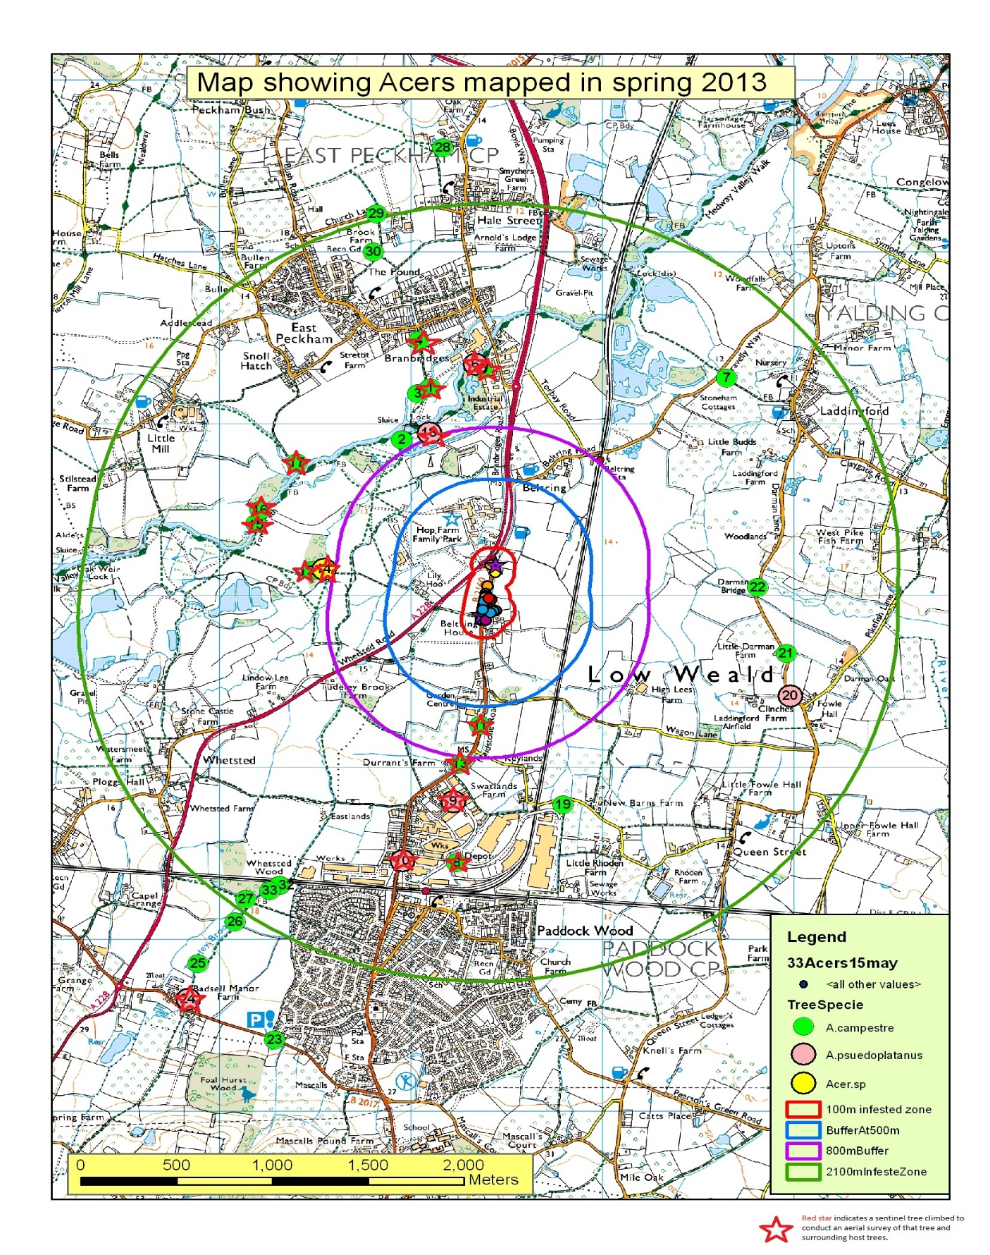

Local awareness campaign
In July 2013 a Fera PHSI visited primary schools in the outbreak area to give presentations on ALB and what to look for to encourage children to monitor for the beetle whilst outside during their summer holidays. Awareness raising leaflets were also delivered to approximately 6000 households in the outbreak area.

Pheromone trapping
In August 2013 twenty ALB pheromone traps were deployed in sentinel trees within the 0.1 – 2.1km zones surrounding the outbreak site. The location of the traps is shown in Fig.2 below. The traps remained in place until December 2013 and were checked every 2 to 3 weeks. There were no findings of ALB in the traps.
Fig.2 Location of ALB pheromone traps in 2013
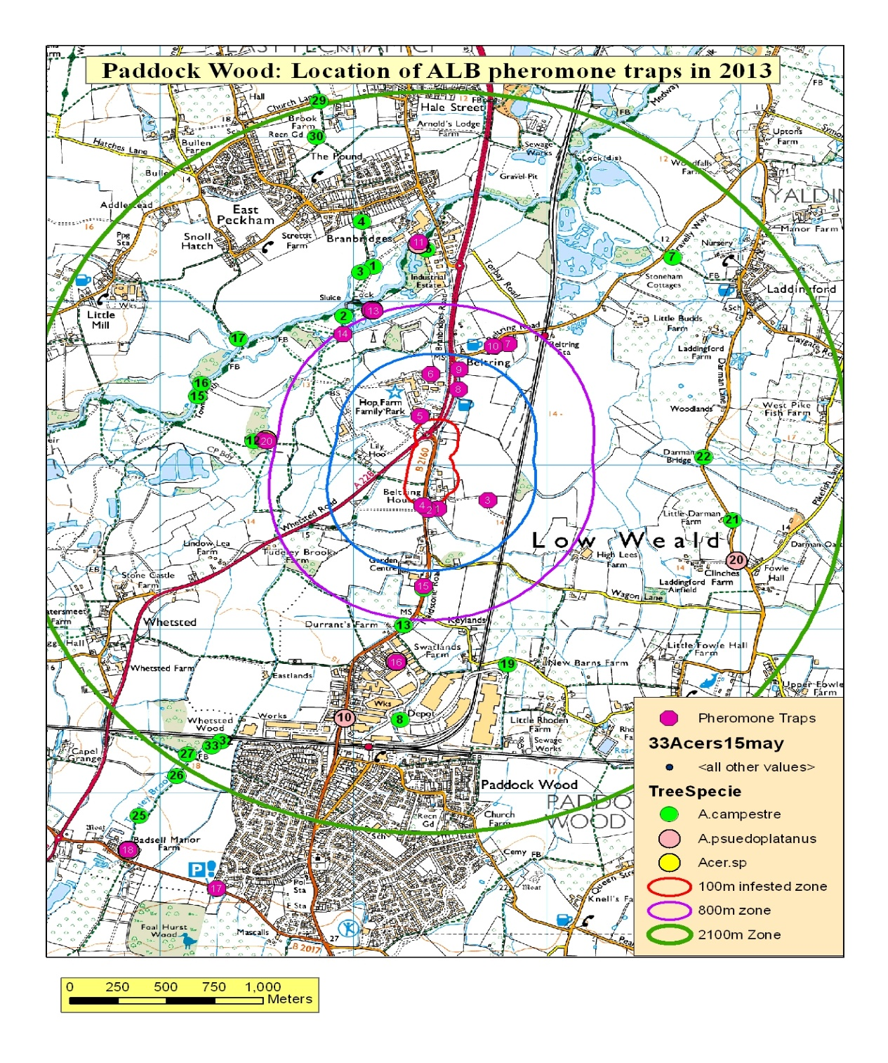

2013-2014 Winter survey
From November 2013 through to February 2014 a winter survey inspecting all trees from 100m to 800m covering an area of 249.3 ha was undertaken by the Fera PHSI. This was an increase in the survey area of 144.4 ha from the 2012-2013 winter survey. No Anoplophora spp. or further symptoms were detected during this survey.

Tree climber survey
In February 2014 to add further assurance to the existing monitoring programme a survey to inspect trees for suspicious symptoms was undertaken using 6 tree climbers per day for a period of 8 weeks. The survey which concluded in April 2014 investigated all specified trees within the first 0.3km surrounding the infestation zone, an area of approximately 40ha. The tree climbers supplied by a local horticultural company based in Kent were trained on site by the Fera PHSI in the symptoms of ALB infestation and also the symptoms of other indigenous pests that may cause similar symptoms. The PHSI remained on site at all times and a good quality digital camera was used to photograph any symptoms seen in the tree and passed to the Fera staff on the ground for further examination. Any suspicious symptoms seen on limbs were removed from the tree to undergo thorough inspection on the ground including the splitting of the samples to look for any tunnelling or damage within the suspect limbs. Fig.3 below shows the location of the trees inspected during the survey. Table 1 provides a weekly breakdown of the number of trees climed and the number of samples taken during the survey. The host species inspected during the survey included Acer campestre, A. pseudoplatanus, A. platanoides, A. saccharum, Alnus, Aesculus hippocastanum, A. indica, Betula, Carpinus, Corylus, Crateagus, Elder, Fraxinus, Malus, Populus, Prunus, Quercus, Rhamnus, Salix and Sambucus.
In general, the sample rate and confidence in finding suspicious symptoms is considered far higher with tree climbers than from inspecting on the ground alone. During this survey it was estimated to be 30%-40% effective from the ground on a good day to 60%-70% when using tree climbers.
No evidence of ALB was found during the tree climbing survey, all suspicious symptoms were diagnosed as (in order of frequency) – Leopard moth (zeuzera pyrina), secondary infection caused by birds opening wounds to bacterial or fungal infection, Goat moth (Cossus cossus), physical damage and indigenous longhorn beetles (such as - Clytus arietis, the wasp beetle).

Fig.3 The location of trees inspected by tree climbers within the 300m zone (40 ha)
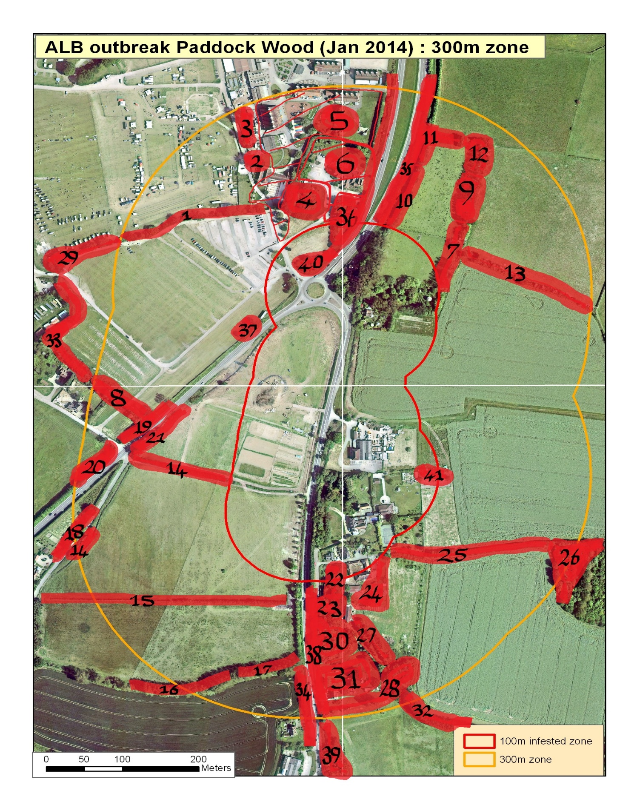

Table 1: Data on tree climbing survey from 100m – 300m
Week Number | Total Trees Climbed (see species list below) | Samples Taken
1 – 18th-21st February 2014 | 124 | 41
2 – 24th-28th February 2014 | 260 | 30
3 – 3rd-7th March 2014 | 348 | 27
4 – 10th – 14th March 2014 | 144 | 30
5 – 17th – 21st March 2014 | 217 | 16
6 – 24th – 28th March 2014 | 282 | 48
7 – 31st March – 4th April 2014 | 94 | 13
8 – 7th – 14th April 2014 | 167 | 8
Sentinel Trees (see map)
7 – 31st March – 4th April 2014 | 19 | 6
8 – 7th – 14th April 2014 | 42 | 6
Grand Total Tree and Sample Numbers - | 1697 | 225
Inspection to Sample Rate | 1 in every 7.5 trees sampled

Next steps
In the absence of any further findings of ALB official surveys will continue at the outbreak location until 2016 before eradication is officially declared. Future surveys will likely contain ground and tree climber elements. Austrian colleagues have also expressed an interest in returning with the sniffer dogs to assist in the winter survey of the outbreak site and in surveys of wood packaging.

