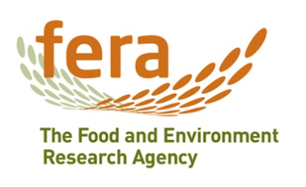

Rapid Pest Risk Analysis for

Phenacoccus solenopsis (Cotton mealybug)
and the closely related P. defectus and P. solani

This document provides a rapid assessment of the risks posed by the pest to the UK in order to assist Risk Managers decide on a response to a new or revised pest threat. It does not constitute a detailed Pest Risk Analysis (PRA) but includes advice on whether it would be helpful to develop such a PRA and, if so, whether the PRA area should be the UK or the EU and whether to use the UK or the EPPO PRA scheme.

STAGE 1: INITIATION

1. What is the name of the pest?
Phenacoccus solenopsis Tinsley (Hemiptera: Pseudococcidae) – solenopsis or cotton mealybug
Synonyms: Phenacoccus cevalliae Cockerell, Phenacoccus gossypiphilous Abbas, Arif & Saeed
There are three nominal species of mealybug Phenacoccus solenopsis Tinsley, P. solani Ferris and P. defectus Ferris that are morphologically and biologically very similar. Hodgson et al. (2008) reviewed the morphological differences between the three taxa, and, based on the morphological variation found in Asian specimens, considered that there was support for the hypothesis that these three species might be environmentally-induced variants of a single species. Both P. defectus and P. solani have been cultured at Fera where they found strong morphological and biological evidence to support the hypothesis that these two species are synonymous, but there is more uncertainty regarding P. solenopsis. Due to the taxonomic uncertainty, leading to possible confusion in the literature, all three nominal species are considered together in this rapid assessment.

2. What is the pest’s status in the EC Plant Health Directive (Council Directive 2000/29/EC) and in the lists of EPPO?
Phenacoccus defectus, P. solani and P. solenopsis are not listed in the EC Plant Health Directive, nor in any of the EPPO lists.

3. What is the reason for the rapid assessment?
Phenacoccus solenopsis is a highly invasive agricultural and horticultural pest that has recently been introduced to Europe (Cyprus) in 2010. In Cyprus it has had a high impact on a range of ornamental plants grown in urban areas, and a medium impact to non-commercial production of aubergine, grapevine, okra and tomato. There have been multiple interceptions of P. solenopsis in England on fresh vegetables from West Africa, and most recently on herbs from Israel and bell peppers from East Africa. Both P. defectus and P. solani have also been introduced to the EU. P. defectus/solani (identity is uncertain) has been found breeding and causing serious damage to succulent plants at a public botanical garden and in private plant collections in the UK. A rapid assessment was requested to help determine if a detailed PRA is required in order to guide policy.

STAGE 2: RISK ASSESSMENT

4. What is the pest’s present geographical distribution?
Phenacoccus defectus, P. solani and P. solenopsis are native to North America.
During the last two decades P. solenopsis has spread from North America (Mexico and USA) to Central America (Belize, Guatemala and Panama), South America (Argentina, Brazil, Chile, Colombia, Ecuador and Galapagos Islands), Caribbean (Cayman Islands, Cuba, Dominican Republic, Guadeloupe, Haiti, Jamaica, Martinique, and Saint Martin & St. Barthelemy), Europe (Cyprus), Africa (Benin, Cameroon, Egypt, Ghana, Nigeria and Sierra Leone), Middle East (Iran and Israel), Asia (China, India, Indonesia, Pakistan, Sri Lanka, Taiwan, Thailand and Vietnam), and Oceania (New Caledonia). This list is likely to be incomplete as the mealybug is spreading rapidly in the tropics. There is a record of P. solenopsis from the Netherlands but this is based on an interception on imported plant material (Jansen, 2004)
In recent decades P. solani has also spread from North America (Canada, Mexico and USA) to Central America (Guatemala), South America (Brazil, Colombia, Ecuador, Peru and Venezuela), Caribbean (Guadeloupe, Netherlands Antilles, Puerto Rico & Vieques Island, and Trinidad and Tobago), Europe (Sicily, Spain), Africa (Cape Verde, South Africa and Zimbabwe), Middle East (Iran and Israel), Asia (India, Japan, Singapore, Taiwan, Thailand, Turkey and Vietnam), and Oceania (Hawaiian Islands and Marshall Islands).
Phenacoccus defectus occurs in North America (Mexico and USA) and has been introduced to Europe (France). Although it has been recorded from the UK, its current status is uncertain as there have been no recent findings (Malumphy, 1997; Williams & Malumphy, 2012).
In summary, the P. solenopsis group has spread from North Amercia throughout the warmer parts of the world.

5. Is the pest established or transient, or suspected to be established/transient in the UK? (Include information on interceptions and outbreaks here).
There have been multiple interceptions of Phenacoccus solenopsis in England on Amaranthus and leafy vegetables from Ghana, 1998 onwards, Nigeria 1996 onwards, Manihot esculenta from Sierra Leone, 2001, and vegetables from Cameroon 1998 (Malumphy, 2005; Williams & Malumphy, 2012). During 2012 there have been four interceptions of P. solenopsis on basil imported from Israel. However, no breeding populations have been found in the UK and it’s status is absent.
Phenacoccus defectus has been found on succulent plants in private plant collections in Lancashire (imported from the USA) and Yorkshire (Malumphy, 1997, 2009). Phenacoccus defectus/solani was found causing severe damage to succulent plants grown indoors at a public botanical garden in Cornwall in 2007, and found outdoors during the summer on succulent plants planted on a public roundabout. The plants were traced back to a commercial nursery in Cornwall, and were originally imported from Italy. The current status of P. defectus and P. solani in the UK is uncertain.

6. What are the pest’s natural and experimental host plants; of these, which are of economic and/or environmental importance in the UK?
Phenacoccus solenopsis is polyphagous feeding on more than 200 plant species assigned to approximately 60 families, with a preference for Asteraceae, Euphorbiaceae, Fabaceae, Malvaceae and Solanaceae. It feeds on a range of important crops grown in the UK, including asparagus, peppers, tomato, aubergine, potato and grapevine. It also feeds on many ornamental plants.
Phenacoccus solani is polyphagous feeding on plants belonging to at least 31 families, with a preference for Asteraceae and Solanaceae. It feeds on a range of important crops grown in the UK, including cabbage, peppers, tomato, aubergine and potato. It also feeds on important flower crops, such as chrysanthemum, and on many common weeds, such as common sowthistle.
Phenacoccus defectus is polyphagous feeding on plants belonging to nine families. It appears to show a preference for Asteraceae and Crassulaceae. None of its host plants are of major economic importance in the UK.

7. If the pest needs a vector, is it present in the UK?
No vector is required. These are free-living organisms.

8. What are the pathways on which the pest is likely to move and how likely is the pest to enter the UK and transfer to a suitable host? (By pathway):

Pathway 1. Growing plants (ornamentals) imported from Europe
All three nominal species are present in Europe and the free movement of their host plants within Europe will allow them to disperse. P. defectus/solani has only been detected once in the UK on growing plants imported from Europe, and P. solenopsis has never been intercepted. However, this lack of interception data may be entirely due to the host plants not being inspected when moved within the EU, and the difficulty of detecting cryptic mealybugs at low densities (they can feed on the roots).

Very  unlikely |  | Unlikely | X | Moderately likely | X | Likely |  | Very  likely

Pathway 2. Growing plants (ornamentals) imported from outside Europe
P. defectus was introduced with ornamental succulent plants imported from California in 1995. The P. solenopsis group is highly invasive and has spread throughout the warmer parts of the world. It is polyphagous, and if accidently introduced to the UK with growing plants (for example on the roots of succulents), it could spread to other ornamental species.

Very  unlikely |  | Unlikely | X | Moderately likely | X | Likely |  | Very  likely

Pathway 3. Fresh produce imported from outside Europe
P. solenopsis is almost ubiquitous on fresh leafy vegetables imported from West Africa. However, this produce is processed shortly after arrival and there is no clear pathway for infested leaves to be transferred to a commercial vegetable grower.

Very  unlikely | X | Unlikely |  | Moderately likely |  | Likely |  | Very  likely

9. How likely is the pest to establish outdoors or under protection in the UK?
Phenacoccus defectus, P. solani and P. solenopsis are very unlikely to be able to establish (overwinter) outdoors in the UK, apart from in exceptionally sheltered areas in large cities, such as London. They are highly likely to be able to establish on indoor plantings, wherever there are suitable hosts. There appears to be no published information available regarding their economic impact to protected cultivation, but a culture of P. defectus/solani kept at the Fera laboratory was highly damaging to small tomato plants.

Outdoors | Very  unlikely | X | Unlikely |  | Moderately likely |  | Likely |  | Very  likely
Under protection |  |  |  |  |  |  |  |  |  | X

10. How quickly could the pest spread in the UK?
Phenacoccus defectus, P. solani and P. solenopsis are more mobile than the mealybugs commonly on indoor plantings in the UK. However, natural dispersal is still likely to be slow, especially as it is likely to be restricted to indoor plantings. It is much more likely to be spread in trade. The related bougainvillea mealybug, Phenacoccus peruvianus, spread very rapidly in the western Mediterranean due to movement in ornamental trade.

Natural dispersal
Very  slowly | X | Slowly |  | Moderate pace |  | Quickly |  | Very  Quickly

Trade
Very  slowly |  | Slowly |  | Moderate pace | X | Quickly |  | Very  Quickly

11. What is the area endangered by the pest?
The endangered area is indoor plantings throughout Britain, wherever there are suitable hosts.

12. What is the pest’s economic, environmental or social impact within its existing distribution?
Phenacoccus solenopsis is an important plant pest, causing major economic, environmental and social impact. Large populations of mealybugs cause general weakening, distortion, defoliation, dieback and death of susceptible plants. Infested plants may also become smothered in honeydew excreted by the mealybugs, which serves as a substrate for the growth of sooty moulds. It has the potential to inflict significant damage to field crops (for example, cotton and tobacco) in all growing regions. Since 2005, it has become a major pest of cotton in Pakistan and with economic and social consequences. Numerous expensive applications of insecticides have been required to produce and protect the cotton crop (e.g. US$ 121.4 million was used in the Punjab in just two months in 2007) (Hodgson et al., 2008). As a result, the additional pest control requirements often lead to a reduced profit margin that affects the standard of living of producers and homeowners. Because of the crop losses and damaged cotton bringing lower prices, many farmers are reported to be interested in cultivating other crops. P. solenopsis is a pest of other commercial crops including a variety of vegetables, grapes, jute, and mesta fiber crops (Hibiscus cannabinus). It is a pest of hibiscus in China and also a serious pest of sweet wormwood (Artemisia annua) in India, which is cultivated as a source of anti-malarial and anti-cancer treatments (CABI, 2012). The pest attacks and damages numerous ornamental plants, with the potential to affect the aesthetic appearance of plants in infested areas, or kill native plants resulting in their displacement by other more aggressive plant species. P. solenopsis was first recorded in Cyprus in 2010, and has since become a damaging pest of a range of ornamental plants, some vegetable crops, and grapevine, grown in private and public gardens, nurseries, and in green urban areas. It has had a high impact to Antirrhinum majus, Dendranthema, Hibiscus sinensis, Hibiscus sensitiphyllum, Hibiscus syriacus, Lantana camara, Myoporum laetum, Petunia, Pittosporum tobira, Osteospermum, Portulaca oleraceae, Solanum rantonetti, and a medium impact to Gaillardia aristata, Hibiscus esculentus, Leucophyllum frutescens, Rhynchospermum jasminoides, Solanum lycopersicum, Solanum melongena and Vitis vinifera. It is very difficult to manage the pest because their populations increase rapidly in the summer months, and they can quickly destroy whole plants (Margarita Hadjistylii, pers. Comm., 2013). It has not had an impact on commercial agricultural production.
There are no precise data on the economic losses caused by P. solani but it is recorded as a pest of stored potato tubers in the USA, tobacco in Zimbabwe, Festuca forage crops in Iran and a major pest of tropical foliage plants in Florida. It is also recorded causing symptoms similar to damping-off to young Emilia and Portulaca oleracea plants in Hawaii and large colonies cause mature plants to collapse. It was first recorded in Sicily in 1999, Israel 2005, Turkey 2008, and in Spain 2011 (ScaleNet, http://www.sel.barc.usda.gov/catalogs/pseudoco/Phenacoccussolani.htm).
Phenacoccus defectus is an occasional pest of succulent plants (Malumphy, 1997). It is recorded from France on ScaleNet, but no details are provided.
Overall, the P. solenopsis group is a major economic pest, primarily in the tropics. There is, however, very little information available on its impact to protected cultivation, and within the EU it has only been recorded to be a pest, primarily in urban areas, in Cyprus.

Phenacoccus solenopsis
Very  small |  | Small |  | Medium |  | Large | X | Very  large
Phenacoccus solani
Very  small |  | Small | X | Medium |  | Large |  | Very  large
Phenacoccus defectus
Very  small | X | Small |  | Medium |  | Large |  | Very  large

13. What is the pest’s potential to cause economic, environmental or social impacts in the UK?
Phenacoccus solenopsis is mainly a tropical species and would be restricted to indoor plantings in the UK. It is likely to have a greater impact on ornamental plants grown in tropical houses in botanical gardens, than in commercial vegetable crops which may not be warm enough for populations to develop to damaging levels (except during the summer months). However, there is a high degree of uncertainty over this and it has been recorded damaging aubergine, grapevine, okra and tomato in Cyprus, and tomato crops in Brazil.
Phenacoccus defectus/solani was found to cause serious damage to a collection of succulent plants at a public botanical garden in Cornwall in 2007. The worst infested plants were destroyed by the plant curators while others were treated with pesticides. Mealybugs collected from the succulent plants were cultured in licensed quarantine facilities at Fera. They easily transferred to tomato plants and the population built up rapidly to the point where the tomato plants were killed by a massive mealybug infestation. There is a potential, therefore, for P. solani to have a high impact to commercial tomato, pepper and other vegetable crops grown in glasshouses in the UK, if appropriate management measures are not taken, although there is a high degree of uncertainty as this is based on a single experiment.
Phenacoccus defectus is unlikely to have an economic impact although it was recorded causing some damage to a private collection of succulent plants in Lancashire in 1995.

Phenacoccus solenopsis
Very  small |  | Small | X | Medium | X | Large |  | Very  large
Phenacoccus solani
Very  small |  | Small | X | Medium | X | Large |  | Very  large
Phenacoccus defectus
Very  small | X | Small |  | Medium |  | Large |  | Very  large

14. What is the pest’s potential as a vector of plant pathogens?
Phenacoccus defectus, P. solani and P. solenopsis are not known to be vectors of any plant pathogen.

STAGE 3: PEST RISK MANAGEMENT

15. What are the risk management options for the UK? (Consider exclusion, eradication, containment, and non-statutory controls; under protection and/or outdoors).

Detection of mealybugs on plants moving in trade is always problematical, as they are small and cryptic, and may occur on the roots. Exclusion of P. solenopsis may be possible as the mealybug has never been intercepted on an imported growing plant. Several of the perennial herbaceous host plants of the P. solenopsis group are already regulated (for non-native leaf-mining flies) by Annex IVA, if imported from outside the EU, and are thus checked by the plant health inspectors on arrival. However, it is well established in Cyprus and is likely to spread within the Mediterranean. Phenacoccus defectus is present in France, and P. solani in Sicily and Spain, and both may be introduced on imported ornamental plants. While these pests are present only in limited areas exclusion may still be possible, however this may depend on whether the pest is associated with an area of major plant production and distribution as there would be no effective control over the main pathway of introduction, that is, on growing plants imported from Europe.
The simplest and most straightforward way of achieving eradication would be destruction of infested plants and precautionary treatment of those remaining. Non-statutory control of mealybugs is usually difficult in practice, and although both contact and systemic insecticides are available, they have not always been effective against P. solenopsis in Cyprus.

16. Summary and conclusion of rapid assessment.

This rapid assessment shows:

Risk of entry – unlikely to moderately likely (on growing plants from within and outside Europe), though with high uncertainty. Very unlikely on fresh produce.
Phenacoccus defectus, P. solani and P. solenopsis are all present in Europe and the free movement of their host plants within Europe will allow them to be dispersed in trade, however, P. defectus/solani has only been detected twice on imported plants and P. solenopsis has never been detected on imported plants.
Risk of establishment – very likely on indoor plantings, very unlikely outdoors
All three nominal species are very likely to be able to establish on indoor plantings, wherever suitable hosts are grown. Phenacoccus defectus and P. solani are more cold-adapted than P. solenopsis.
Rate of spread – very slow (natural) to moderate (in trade)
Economic impact – very small (P. defectus) to moderate (P. solani and P. solenopsis) impact to vegetable crops and grapevine
Both P. solenopsis and P. solani are pests of a wide range of vegetable crops and ornamental plants. P. defectus/solani was cultured on tomato at Fera and the population developed rapidly, eventually killing the plants. Phenacoccus solani and P. solenopsis could have a small to medium impact to glasshouse vegetable crops, and possibly grapevine.
Endangered area – indoor plantings
Risk management – may be controlled by using the same products currently used for other glasshouse mealybugs
In the absence of phytosanitary measures Phenacoccus defectus, P. solani and P. solenopsis may enter the UK, currently likely to be a rare event, but it may depend on if the pests spread within the EU. All three mealybugs may be controlled using the same products used for other mealybugs already present in the UK.

17. Is there a need for a detailed PRA? If yes, select the PRA area (UK or EU) and the PRA scheme (UK or EPPO) to be used.

A more detailed PRA does not seem to be appropriate at this time for this pest. Some of the literature is quite confusing regarding the taxonomy of these three species and is unlikely to be resolved soon.

No | X

Yes |  | PRA area: UK or EU |  | PRA scheme: UK or EPPO

18. IMAGES OF PEST
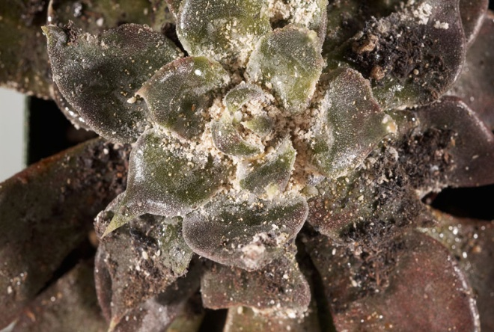 |  | 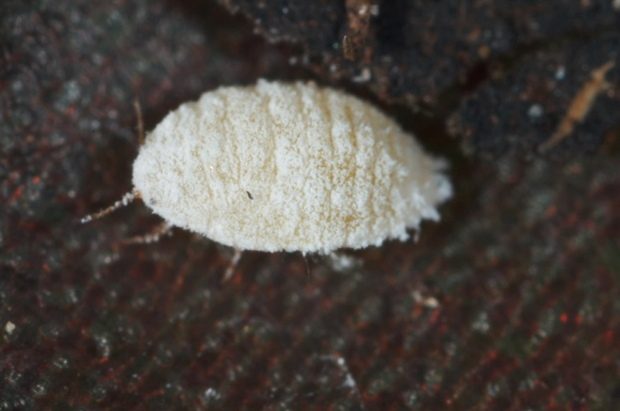
A heavy infestation of Phenacoccus solani killing Echeveria plants at a botanical garden |  | Adult female Phenacoccus solani

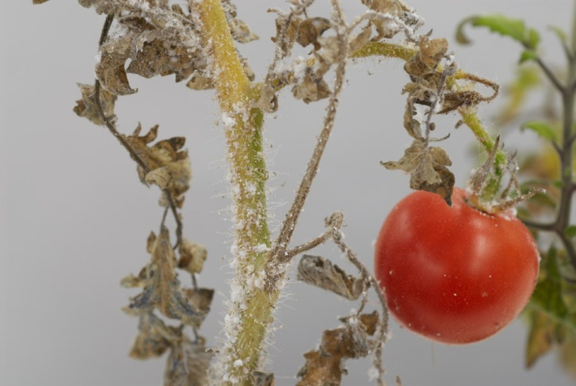 |  | 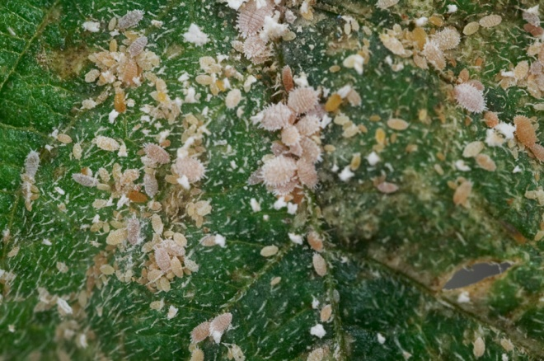
Tomato plant killed by infestation of Phenacoccus solani at Fera laboratory |  | Phenacoccus solani on tomato foliage

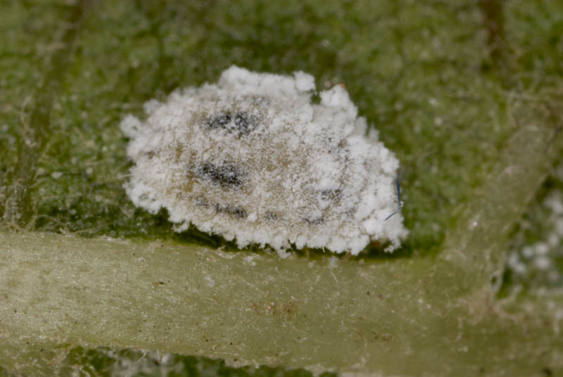 |  | 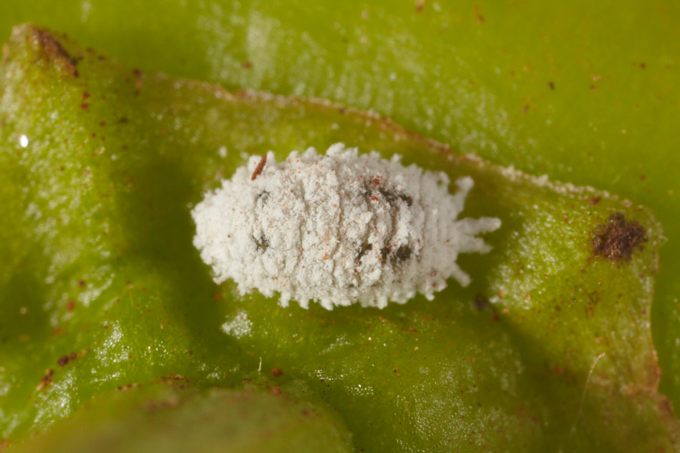
Close up of Phenacoccus solenopsis on African leafy vegetables |  | Close up of Phenacoccus solenopsis on Capsicum from Kenya

19. Given the information assembled within the time scale required, is statutory action considered appropriate / justified?

Statutory action is not considered to be necessary on the majority of fresh produce, the only commodity on which it has been intercepted, because successful entry is very unlikely by this pathway. However, action should be taken if found on plants for planting because, if found on this pathway, entry is much more likely and two of these nominal species, P. solani and P. solenopsis, could transfer between hosts and cause serious damage to tomatoes. Interceptions have been made on imported herbs and there is some concern that action should be taken on this commodity if there is the potential that these herbs could be planted, rather than being already cut. These mealybugs are likely to present more of a risk to southern EU countries than the UK.

Yes  Statutory action | X | No  Statutory action | X

REFERENCES
CABI. 2012. Phenaoccus solenopsis. Invasive species Compendium. http://www.cabi.org/isc/?compid=5&dsid=109097&loadmodule=datasheet&page=481&site=144 Acessed 15 October 2012.
Hodgson, C.J., Abbas, G., Arif, M.J., Saeed, S. & Karar, H. 2008. Phenacoccus solenopsis Tinsley (Sternorrhyncha: Coccoidea: Pseudococcidae), an invasive mealybug damaging cotton in Pakistan and India, with a discussion on seasonal morphological variation. Zootaxa 1913: 1-35.
Jansen MG, 2004. An updated list of scale insects (Hemiptera, Coccoidea) from imported interceptions and greenhouses in the Netherlands. In: Proceedings of the X International Symposium on Scale Insect Studies, 19th-23rd April 2004. 147-165 pp.
Malumphy, C. 1997. Imperfect mealybug, Phenacoccus defectus Ferris (Homoptera, Coccoidea, Pseudococcidae), a pest of ornamental succulent plants, new to Britain. Entomologist’s Gazette 48, 285-288.
Malumphy, C. 2005. Insects and mites intercepted on fresh cassava (Manihot esculenta) foliage imported into England and Wales. Entomologist's Gazette 56, 53-63.
Malumphy, C. 2009. The scale insects (Hemiptera: Coccoidea) of Watsonian Yorkshire. The Naturalist 134, 57-74.
Wang, Y.P., Wu, S.A. & Zhang, R.Z. 2009. Pest risk analysis of a new invasive pest, Phenacoccus solenopsis, to China. Chinese Bulletin of Entomology 46, 101-106
Williams, D.J. & Malumphy, C. 2012. Mealybugs of Great Britain: A revised and updated checklist (Hemiptera: Coccoidea: Pseudococcidae). Entomologist’s Monthly Magazine 148, 81-94.

Date of production: 17th January 2013
Version no.: 5
Author (s): Chris Malumphy, Richard Baker & Helen Anderson

http://europa.eu.int/eur-lex/en/consleg/pdf/2000/en_2000L0029_do_001.pdf
http://www.eppo.org/QUARANTINE/quarantine.htm

