EUROPEAN AND MEDITERRANEAN PLANT PROTECTION ORGANIZATION
ORGANISATION EUROPEENNE ET MEDITERRANEENNE
POUR LA PROTECTION DES PLANTES
06-12730 (06-12631, 06-12557)

PEST RISK ANALYSIS FOR Phytophthora lateralis rev 1

Pest risk analyst: Panel for P. lateralis following the EPPO Decision support Scheme for quarantine pests

Draft 08 February 2006

Stage 1: Initiation
1 What is the reason for performing the PRA? |  |  |  |  | Identification of a single pest that may pose a problem to the EPPO region
2 Enter the name of the pest |  |  |  |  | Phytophthora lateralis
2A Indicate the type of the pest |  |  | Fungus or fungus-like
2B Indicate the taxonomic position |  |  |  |  | Kingdom-Chromista, Phylum-Oomycota, Order-Pythiales, Family-Pythiaceae, Genus-Phytophthora
3 Clearly define the PRA area |  |  |  |  | EPPO region
4 Does a relevant earlier PRA exist? |  |  | Yes |  | Pest Risk Analyses have been conducted on this pest in the Netherlands and France (draft only). A datasheet has been prepared for the UK and a PRA is currently being drafted. Pest risk management options have been identified in Great Britain.
5 Is the earlier PRA still entirely valid, or only partly valid (out of date, applied in different circumstances, for a similar but distinct pest, for another area with similar conditions)? |  |  | Not entirely valid |  | Existing PRAs were not prepared for the EPPO region and need to be updated as they were performed in 1999 (French PRA) and 2001 (Dutch PRA). The draft UK PRA (2006) is for the UK only.
Stage 2A: Pest Risk Assessment - Pest categorization
6 Does the name you have given for the organism correspond to a single taxonomic entity which can be adequately distinguished from other entities of the same rank? |  |  | Yes
8 Is the organism in its area of current distribution a known pest (or vector of a pest) of plants or plant products? |  |  | Yes |  | The organism is considered to be a pest in its current area of distribution.
10 Does the pest occur in the PRA area? |  |  | No |  | The pest is not known to be present in the EPPO region. Outbreaks have been declared in France (two outbreaks from a single origin) and the Netherlands but these are considered eradicated. General surveillance does not indicate that the pest is present in the PRA area.
12 Does at least one host-plant species (for pests directly affecting plants) or one suitable habitat (for non parasitic plants) occur in the PRA area (outdoors, in protected cultivation or both)? |  |  | Yes |  | Chamaecyparis spp. and Rhododendron spp. are common ornamental plants in most of the region.
14 Does the known area of current distribution of the pest include ecoclimatic conditions comparable with those of the PRA area or sufficiently similar for the pest to survive and thrive (consider also protected conditions)? |  |  | Yes
15 Could the pest by itself, or acting as a vector, cause significant damage or loss to plants or other negative economic impacts (on the environment, on society, on export markets) ? |  |  | Yes or uncertain
16 This pest could present a risk to the PRA area. |  |  |  |  | The pest is not established in the PRA area, should it enter it has the potential for establishment and the potential to have economic impacts. Therefore the criteria of quarantine pest status are met .
Section 2B: Pest Risk Assessment - Probability of introduction/spread and of potential economic consequences
Note: If the most important pathway is intentional import, do not consider entry, but go directly to establishment. Spread from the intended habitat to the unintended habitat, which is an important judgement for intentionally imported organisms, is covered by questions 1.33 and 1.35. |  | Continue with questions of entry
1.2 Note down the relevant pathways, then estimate the total number of distinct pathways, by multiplying the number of relevant pathways by the number of relevant origins and the number of relevant end uses. |  | Very few |  | Host plants:  The most important hosts of P. lateralis are Chamaecyparis spp. particularly C. lawsoniana (Tucker and Milbrath, 1942)  Taxus brevifolia is an occasional host (first reported in DeNitto and Kliejunas, 1991)  According to Hansen (E. Hansen, Oregon, USA, 2006, personal communication) published reports on hosts other than cedars (C. lawsoniana or Chamaecyparis spp.) and T. brevifolia are considered to be misidentifications.  Whilst not considered further in this analysis the first reports of these are :  Actinidia chinensis (Robertson, 1982); Actinidia deliciosa (Pennycook, 1989; Gadgil, 2005); Catharanthus roseus (Abad et al., 1994); Juniperus horizontalis (Abad et al., 1994); Kalmia latifolia (Abad et al., 1994); Photinia x fraseri (Abad et al., 1994); Rhododendron sp. (Hoitink and Schmitthenner, 1974); Rhododendron sp. (azalea) (Abad et al., 1994); Platycladus orientalis (syn. Thuja orientalis) Hall, 1991.  There is no report of seed transmission so this was not considered by the Panel.  P. lateralis can also be found on organic matter in the soil from infested land (Hansen and Hamm 1996).  Branches and foliage of Chamaecyparis spp. and Taxus brevifolia were not considered as a realistic pathway.  Consequently pathways considered for P. lateralis in the analysis, taking the affected areas of North America as the start of each pathway:  1. Plants for planting of Chamaecyparis spp. (as cuttings or with growing media attached) from the USA and Canada,  2. Plants for planting of Taxus brevifolia (as cuttings or with growing media attached) from the USA and Canada,  3. Plants for planting of non host plants with growing media attached from the USA and Canada  4. Soil from the USA and Canada as a commodity  5. Soil from the USA and Canada as a contaminant on used machinery  6. Soil from the USA and Canada as a contaminant on footwear).
Pathway 1 |  |  |  | Plants for planting of Chamaecyparis spp. (cuttings or with growing media attached)
1.4 Is the prevalence of the pest on the pathway at origin likely to be high, taking into account factors like the prevalence of the pest at origin, the life stages of the pest, the period of the year? |  | Likely |  | P. lateralis is a common pest in the forest where the pest occurs. Nurseries producing Chamaecyparis spp. in the USA and Canada used to be located in the vicinity of forests and many became contaminated (Hansen 1985;Kliejunas, 1981). Most of these nurseries have gone out of business and there is uncertainty on how many Chamaecyparis spp. are grown in non specialised nurseries. Recent survey data are needed to make a proper judgement. The risk from plants of Chamaecyparis lawsoniana taken from nature is high.  As a conclusion based on data available, the Panel considered that the prevalence of the pest on the pathway at origin was likely to be high.
1.5 Is the prevalence of the pest on the pathway at origin likely to be high, taking into account factors like cultivation practices, treatment of consignments? |  | Likely |  | The experience in Europe with other Phytophthora spp. such as Phytophthora cinnamomi indicates that they are usually favoured by nursery practices such as irrigation (humid conditions re-circulation of untreated irrigation water), close plant proximity etc. It should be noted that good plant production practices that might reduce the prevalence of the pest e.g. disinfection of tools, treatment of re-circulated water, good drainage and fungicide application are anticipated in the two countries where the pest is present. Applying Phytophthora controlling fungicides may not eradicate the pest but could mask the presence of P. lateralis on nursery stock and increase the risk of introducing the disease (Roth et al , 1987). As a conclusion, the measures applied in nurseries might only partially reduce the prevalence level.  Plants taken from nature are not subject to cultivation or treatment.  As a conclusion the Panel considered that the prevalence of the pest was likely to be high taking into account factors like cultivation practices and treatment of consignments.
1.6 How large is the volume of the movement along the pathway? |  | No judgement |  | The import of plants for planting of Chamaecyparis spp. is prohibited in at least 27 countries out of 47 EPPO members, consequently this question was difficult to answer. Information on imports into the remaining countries was not available to the Panel.
1.7 How frequent is the movement along the pathway? |  | No judgement |  | The import of plants for planting of Chamaecyparis spp. is prohibited in at least 27 countries out of 47 EPPO members, consequently this question was difficult to answer. Information on imports into the remaining countries was not available to the Panel.
1.8 How likely is the pest to survive during transport /storage? |  | Very likely |  | As the pest is associated with the plant, Chamaecyparis spp., the primary conditions for survival are fulfilled. Many pests from the Chromista group have life stages that allow survival during transport and storage. P. lateralis has two long lived spore stages (chlamydospores and oospores).  As a conclusion the Panel considered that P. lateralis is very likely to survive during transport and storage.
1.9 How likely is the pest to multiply/increase in prevalence during transport /storage? |  | Moderately likely |  | In the event of an active infection on Chamaecyparis spp., multiplication is possible down to 2°C (Hall, 1991). During transport, plants are assumed to be in close contact and in case of humid transport conditions, this may favour multiplication.  If P. lateralis is just present as resting spores multiplication will be less likely.  Air transport would be less likely to favour multiplication because of the shorter duration compared to other means of transport.  The Panel considered that it was moderately likely that the pest would multiply during transport or storage.
1.10 How likely is the pest to survive or remain undetected during existing phytosanitary measures? |  | Very likely |  | Phytosanitary measures are in place in some EPPO countries but mainly relate to freedom from insects on imported conifer material. General requirements on imported material are included in the EU Plant Health Directive (Annex IVAI) for trees and shrubs intended for planting and for growing media attached to plants for planting. These measures mainly refer to inspection for freedom of symptoms of pests or treatment to eliminate them. Fungicidal treatment is not considered suitable for P. lateralis as it is unlikely to be eradicated and symptom expression may be suppressed.  The Panel considered that because of the different life stages of the pest, it is very likely that the pest will survive or remain undetected during existing phytosanitary measures.
1.11 How widely is the commodity to be distributed throughout the PRA area? |  | Widely |  | As the import of plants for planting of Chamaecyparis spp. is prohibited in at least 27 countries out of 47 EPPO members, the Panel considered that it was a theoretical pathway. Nevertheless it considered that if this plant was to be imported it would be widely distributed in the EPPO region with the exception of Siberia where the plant could not survive. This is because Chamaecyparis is a commonly-planted ornamental.  The Panel considered that the commodity would be widely distributed throughout the PRA area (except Siberia)
1.12 Do consignments arrive at a suitable time of year for pest establishment? |  | Yes |  | As the import of plants for planting of Chamaecyparis spp. is prohibited in at least 27 countries out of 47 EPPO members, the Panel considered that it was a theoretical pathway. Nevertheless it considered that if this plant was to be imported it would be expected to arrive at a suitable time for pest establishment because the pathogen will persist in the imported plant.
1.13 How likely is the pest to be able to transfer from the pathway to a suitable host or habitat? |  | Very likely |  | The pest will be able to transfer from plants for planting arriving on a nursery to other potential host plants. It may contaminate soil via swimming zoospores. A similar situation would arise if it arrives in amenity areas or landscapes where host plants are present.  The Panel considered that the pest was very likely to transfer from the pathway to a suitable host.
1.14 How likely is the intended use of the commodity (e.g. processing, consumption, planting, disposal of waste, by-products) to aid transfer to a suitable host or habitat? |  | Very likely |  | The intended use (planting) is very likely to aid transfer to a suitable host.
1.15 Do other pathways need to be considered? |  | Yes (return to question 1.3 for next pathway)
Pathway 2 |  |  |  | Plants for planting of Taxus brevifolia
1.4 Is the prevalence of the pest on the pathway at origin likely to be high, taking into account factors like the prevalence of the pest at origin, the life stages of the pest, the period of the year? |  | Moderately likely |  | Taxus brevifolia and Chamaecyparis spp., especially C. lawsoniana occur naturally together in the same area, at least in the USA. In natural ecosystems there is a host differentiation between C. lawsoniana and T. brevifolia, Taxus mainly becoming infected if there are many infected C. lawsoniana in the surrounding area in association with water. Inoculation experiments have shows that T. brevifolia is much less susceptible than C. lawsoniana. (Hansen, 2000, Murray and Hansen, 1997). Plants for planting grown on a nursery may still become infected in the presence of the pest but because of host susceptibility the pest prevalence may be different on T. brevifolia.  The Panel considered that the prevalence of the pest on the pathway is moderately likely to be high
1.5 Is the prevalence of the pest on the pathway at origin likely to be high, taking into account factors like cultivation practices, treatment of consignments? |  | Likely |  | The experience in Europe with other Phytophthora spp. such as P. cinnamomi indicates that they are usually favoured by nursery practices such as irrigation (humid conditions re-circulation of untreated irrigation water), plant proximity etc. It should be noted that good plant production practices that might reduce the prevalence of the pest e.g. disinfection of tools, treatment of re-circulated water, good drainage and fungicide application are anticipated in the two countries where the pest is present. Applying Phytophthora controlling fungicides may not eradicate the pest but could mask the presence of P. lateralis on nursery stock. This is considered to pose an extra danger. As a conclusion, the measures applied in nurseries might only partially reduce the likelihood of prevalence.  Plants taken from nature are not subject to cultivation or treatment.  As a conclusion the Panel considered that the prevalence of the pest was still likely to be high even taking into account factors like cultivation practices and treatment of consignments.
1.6 How large is the volume of the movement along the pathway? |  | Minimal |  | The amount of imports of plants for planting of Taxus brevifolia into the PRA area is not known. Global ornamental trade data indicate a total amount of 75 (1999), 130 (2002) and 50 (2001 and 2003) tonnes of ornamental nursery stock imported in 2003 from North America to the EU (AIPH, International Statistics on Flowers and Plants).  Based on these low figures, the Panel considered the movement along the pathway is minimal
1.7 How frequent is the movement along the pathway? |  | No judgement |  | No information
1.8 How likely is the pest to survive during transport /storage? |  | Very likely |  | As the pest is associated with one of its host plants, Taxus brevifolia, the primary conditions for survival are fulfilled. Many pests from the Chromista group have life stages that allow survival during transport and storage. P. lateralis has two long lived spore stages (chlamydospores and oospores).  As a conclusion the Panel considered that P. lateralis is very likely to survive during transport and storage.
1.9 How likely is the pest to multiply/increase in prevalence during transport /storage? |  | Moderately likely |  | P. lateralis is not as well adapted to T. brevifolia which is less susceptible to P. lateralis than Chamaecyparis , but the pest is able to grow on T. brevifolia (Murray and Hansen 1997).  As a conclusion the Panel considered that P. lateralis is moderately likely to multiply during transport and transit.
1.10 How likely is the pest to survive or remain undetected during existing phytosanitary measures? |  | Very likely |  | Phytosanitary measures are in place in some EPPO countries but mainly relate to freedom from insects on imported conifer material. General requirements on imported material are included in the EU Plant Health Directive (Annex IVAI) for tree and shrubs intended for planting and for growing media attached to plants for planting. These measures mainly refer to inspection for freedom of symptoms of pests or treatment to eliminate them. Such requirements are not considered suitable for P. lateralis on T. brevifolia as infected plants may be asymptomatic (Murray and Hansen, 1997) and symptom expression may be suppressed by a fungicide treatment.  The Panel considered that because of the different life stages of the pest, it is very likely that the pest will survive or remain undetected during existing phytosanitary measures.
1.11 How widely is the commodity to be distributed throughout the PRA area? |  | Limited |  | T. brevifolia was not considered by the Panel as a significant plant for the EPPO area
1.12 Do consignments arrive at a suitable time of year for pest establishment? |  | Yes |  | The Panel considered that plants will always arrive at a suitable time for pest establishment because the pathogen will persist in the imported plant.
1.13 How likely is the pest to be able to transfer from the pathway to a suitable host or habitat? |  | Likely |  | Outbreaks related to plants introduced with infested soil are reported (Hansen et al. 2000). Nevertheless, the amount of inoculum likely to be associated with T. brevifolia is likely to be less than with Chamaecyparis spp.  The Panel considered that the pest is likely to transfer to a suitable host.
1.14 How likely is the intended use of the commodity (e.g. processing, consumption, planting, disposal of waste, by-products) to aid transfer to a suitable host or habitat? |  | Very likely |  | The intended use (planting) is very likely to aid transfer to a suitable host.
Pathway 3 |  |  |  | Plants for planting of non-host plants with growing media attached
1.4 Is the prevalence of the pest on the pathway at origin likely to be high, taking into account factors like the prevalence of the pest at origin, the life stages of the pest, the period of the year? |  | Moderately likely |  | The Panel commented that if the field in which non-host plants are being produced had been contaminated (contamination within the past 7 years) the growing media is likely to be infested.  The Panel considered that the prevalence of the pest on the pathway at origin was moderately likely to be high.
1.5 Is the prevalence of the pest on the pathway at origin likely to be high, taking into account factors like cultivation practices, treatment of consignments? |  | No judgement |  | No information
1.6 How large is the volume of the movement along the pathway? |  | Minimal |  | Global ornamental trade data indicate a total amount of 75 (1999), 130 (2002) and 50 (2001 and 2003) tonnes of ornamental nursery stock imported in 2003 from North America to the EU (AIPH, International Statistics on Flowers and Plants).  Based on these low figures, the Panel considered the movement along the pathway is minimal
1.7 How frequent is the movement along the pathway? |  | No judgement |  | No information
1.8 How likely is the pest to survive during transport /storage? |  | Likely |  | The pest can survive on organic matter in the soil for at least 3 years (Hansen et al, 2000).  The Panel considered that the pest was likely to survive during transport or storage
1.9 How likely is the pest to multiply/increase in prevalence during transport /storage? |  | Very unlikely |  | In the absence of host material sporulation and therefore multiplication is very unlikely  The Panel considered that the pest was very unlikely to survive multiply during transport or storage
1.10 How likely is the pest to survive or remain undetected during existing phytosanitary measures? |  | Very likely |  | General requirements on imported material are included in the EU Plant Health Directive (Annex IVAI) for growing media attached to plants for planting but these do not address the risk from P. lateralis. Outbreaks related to plants introduced with infested soil are reported (Hansen et al., 2000).  The Panel considered that the pest was very likely to survive or remain undetected during existing phytosanitary measures.
1.11 How widely is the commodity to be distributed throughout the PRA area? |  | Widely |  | The Panel considered that non-host plants would be widely distributed in the EPPO region, given the potential variety of imported material.  The Panel considered that the commodity would be widely distributed in the PRA area.
1.12 Do consignments arrive at a suitable time of year for pest establishment? |  | Yes |  | The Panel considered that consignments arrive at a suitable time because the pathogen may persist in the growing media attached to the imported material.
1.13 How likely is the pest to be able to transfer from the pathway to a suitable host or habitat? |  | Moderately likely |  | In the case of non-host plants, the transfer of the pest to a suitable host is only possible through transfer from associated growing media to waterways and drainage (Murray and Hansen, 1997).  The Panel considered that the pest is moderately likely to transfer to a suitable host.
1.14 How likely is the intended use of the commodity (e.g. processing, consumption, planting, disposal of waste, by-products) to aid transfer to a suitable host or habitat? |  | Very likely |  | The intended use (planting) is very likely to aid transfer to a suitable host.
Pathway 4 |  |  |  | Soil/growing medium (with organic matter) as a commodity
1.4 Is the prevalence of the pest on the pathway at origin likely to be high, taking into account factors like the prevalence of the pest at origin, the life stages of the pest, the period of the year? |  | Likely |  | The Panel commented that as P. lateralis persists in roots and roots fragments for years after the tree is killed (Hansen et al, 2000), soil/growing medium (with organic matter) coming from an area where the pest is present is very likely to be infested. Nevertheless, populations in the soil are very low (Hansen et al, 2000). Whether the population is high depends upon what is being measured (i.e. concentration of chlamydospores or oospores per unit weight or volume) and where the soil/growing medium (with organic matter) is obtained from. Measuring spore populations in soil/growing medium (with organic matter) is difficult.  The Panel considered that the prevalence of the pest on the pathway at origin is likely to be high.
1.5 Is the prevalence of the pest on the pathway at origin likely to be high, taking into account factors like cultivation practices, treatment of consignments? |  | Likely |  | The pest is very persistent because it produces resilient chlamydospores and oospores. Treatments are not effective in eradicating the pest from soil/growing medium (with organic matter).  The Panel considered that the prevalence of the pest on the pathway at origin is likely to be high.
1.6 How large is the volume of the movement along the pathway? |  | No judgement |  | Soil/growing medium (with organic matter) as a commodity is a closed pathway (prohibited) in many EPPO countries. Annex IIIA of the EU Plant Health Directive prohibits imports into the 25 Member States of the EU from many other countries including the USA and Canada. No specific information was available to the Panel on imports into the remaining EPPO countries.
1.7 How frequent is the movement along the pathway? |  | No judgement |  | No information available
1.8 How likely is the pest to survive during transport /storage? |  | Likely |  | The pest can survive on organic matter in the soil/growing medium (with organic matter) at least 3 years (Hansen et al, 2000).  The Panel considered that the pest is likely to survive during transport/storage
1.9 How likely is the pest to multiply/increase in prevalence during transport /storage? |  | Very unlikely |  | In the absence of host material sporulation and therefore multiplication is very unlikely.  The Panel considered that the pest is very unlikely to multiply during transport /storage
1.10 How likely is the pest to survive or remain undetected during existing phytosanitary measures? |  | Very likely |  | Soil/growing medium (with organic matter) as a commodity is usually prohibited from third countries including the USA and Canada into at least 25 of the 47 countries in the EPPO region. Despite this pathway being a closed pathway the pest would survive and remain undetected during existing phytosanitary measures should importation be permitted or if other non-EU EPPO countries permitted entry.  The Panel considered that the pest is very likely to survive or remain undetected during existing phytosanitary measures
1.11 How widely is the commodity to be distributed throughout the PRA area? |  | No judgement |  | See 1.10. Soil/growing medium (with organic matter) as a commodity is a closed pathway in many EPPO countries.
1.12 Do consignments arrive at a suitable time of year for pest establishment? |  | No judgement |  | See 1.10. Soil/growing medium (with organic matter) as a commodity is a closed pathway in many EPPO countries.
1.13 How likely is the pest to be able to transfer from the pathway to a suitable host or habitat? |  | Moderately likely |  | The Panel considered that the possibility for the pest to transfer to a suitable host is difficult to judge and depends on the intended use of the soil/growing medium (with organic matter).  The Panel considered that the pest is moderately likely to be able to transfer from the pathway to a suitable host or habitat
1.14 How likely is the intended use of the commodity (e.g. processing, consumption, planting, disposal of waste, by-products) to aid transfer to a suitable host or habitat? |  | Moderately likely |  | See answer to question 1.13
Pathway 5 |  |  |  | Soil as a contaminant on used machinery.
1.4 Is the prevalence of the pest on the pathway at origin likely to be high, taking into account factors like the prevalence of the pest at origin, the life stages of the pest, the period of the year? |  | Likely |  | The Panel commented that as P. lateralis persists in roots and roots fragments for years after the tree is killed (Hansen et al, 2000), soil/growing medium (with organic matter) coming from an area where the pest is present is very likely to be infested. Nevertheless, populations in the soil are very low (Hansen et al, 2000).  The Panel considered that the prevalence of the pest on the pathway at origin is likely to be high.
1.5 Is the prevalence of the pest on the pathway at origin likely to be high, taking into account factors like cultivation practices, treatment of consignments? |  | Likely |  | The pest is very persistent because it produces resilient chlamydospores and oospores. Treatments are not effective in eradicating the pest from soil.  The Panel considered that the prevalence of the pest on the pathway at origin is likely to be high.
1.6 How large is the volume of the movement along the pathway? |  | No judgement |  | The Panel is unable to judge the extent of the movement of soil as contaminant on used machinery.
1.7 How frequent is the movement along the pathway? |  | No judgement |  | No information available
1.8 How likely is the pest to survive during transport /storage? |  | Likely |  | The pest can survive on organic matter in the soil for at least 3 years (Hansen et al, 2000).  The Panel considered that the pest is likely to survive during transport/storage
1.9 How likely is the pest to multiply/increase in prevalence during transport /storage? |  | Very unlikely |  | In the absence of host material sporulation and therefore multiplication is very unlikely.  The Panel considered that the pest is very unlikely to multiply during transport /storage
1.10 How likely is the pest to survive or remain undetected during existing phytosanitary measures? |  | Very likely |  | Soil as such is prohibited in most EPPO countries which has the consequence that soil as a contaminant should not be allowed. Nevertheless in many countries of the EPPO region there is no general requirement that used machinery should be cleaned.  The Panel considered that the pest is very likely to survive or remain undetected during existing phytosanitary measures
1.11 How widely is the commodity to be distributed throughout the PRA area? |  | Very widely |  | Soil as a contaminant can be very widely distributed in the PRA area
1.12 Do consignments arrive at a suitable time of year for pest establishment? |  | Yes |  | The arrival of soil as a contaminant at any time would be suitable for pest establishment
1.13 How likely is the pest to be able to transfer from the pathway to a suitable host or habitat? |  | Moderately likely |  | The Panel considered that the possibility for the pest to transfer to a suitable host is difficult to judge and depends on the final destination of the machinery (or footwear).  The Panel considered that the pest is moderately likely to be able to transfer from the pathway to a suitable host or habitat.
1.14 How likely is the intended use of the commodity (e.g. processing, consumption, planting, disposal of waste, by-products) to aid transfer to a suitable host or habitat? |  | Moderately likely |  | See answer to question 1.13
Pathway 6 |  |  |  | Soil as a contaminant on footwear
1.4 Is the prevalence of the pest on the pathway at origin likely to be high, taking into account factors like the prevalence of the pest at origin, the life stages of the pest, the period of the year? |  | Likely |  | The Panel commented that as P. lateralis persists in roots and roots fragments for years after the tree is killed (Hansen et al, 2000), soil/growing medium (with organic matter) coming from an area where the pest is present is very likely to be infested. Nevertheless, populations in the soil are very low (Hansen et al, 2000).  The Panel considered that the prevalence of the pest on the pathway at origin is likely to be high.
1.5 Is the prevalence of the pest on the pathway at origin likely to be high, taking into account factors like cultivation practices, treatment of consignments? |  | Likely |  | The pest is very persistent because it produces resilient chlamydospores and oospores. Treatments are not effective in eradicating the pest from soil.  The Panel considered that the prevalence of the pest on the pathway at origin is likely to be high.
1.6 How large is the volume of the movement along the pathway? |  | No judgement |  | The Panel is unable to judge the extent of the movement of soil as contaminant.
1.7 How frequent is the movement along the pathway? |  | No judgement |  | No information available
1.8 How likely is the pest to survive during transport /storage? |  | Likely |  | The pest can survive on organic matter in the soil for at least 3 years (Hansen et al, 2000).  The Panel considered that the pest is likely to survive during transport/storage
1.9 How likely is the pest to multiply/increase in prevalence during transport /storage? |  | Very unlikely |  | In the absence of host material sporulation and therefore multiplication is very unlikely.  The Panel considered that the pest is very unlikely to multiply during transport /storage
1.10 How likely is the pest to survive or remain undetected during existing phytosanitary measures? |  | Very likely |  | No measures are in place for soil as a contaminant on footwear.  The Panel considered that the pest is very likely to survive or remain undetected during existing phytosanitary measures
1.11 How widely is the commodity to be distributed throughout the PRA area? |  | Very widely |  | Soil as a contaminant on footwear can be very widely distributed in the PRA area
1.12 Do consignments arrive at a suitable time of year for pest establishment? |  | Yes |  | The arrival of soil as a contaminant at any time would be suitable for pest establishment
1.13 How likely is the pest to be able to transfer from the pathway to a suitable host or habitat? |  | Moderately likely |  | The Panel considered that the possibility for the pest to transfer to a suitable host is difficult to judge and depends on the final destination of the traveller (footwear).  The Panel considered that the pest is moderately likely to be able to transfer from the pathway to a suitable host or habitat.
1.14 How likely is the intended use of the commodity (e.g. processing, consumption, planting, disposal of waste, by-products) to aid transfer to a suitable host or habitat? |  | Moderately likely |  | See answer to question 1.13
The overall probability of entry should be described and risks presented by different pathways should be identified. |  | The probability of entry varies with the pathway |  | 1. Plants for planting of Chamaecyparis spp. (as cuttings or plants with growing medium attached) from the USA and Canada: medium, volume of trade is in any case assumed to be low.  2. Plants for planting of Taxus brevifolia (as cuttings or plants with growing medium attached) from the USA and Canada: low, specialist plant, less susceptible than Chamaecyparis spp.  3. Plants for planting on non host plants with growing media attached from the USA and Canada: low  4. Soil/Growing medium from the USA and Canada as a commodity: medium, depends on the intended use of the soil  5. Soil from the USA and Canada as contaminant on machinery: difficult to assess, depends on end use  6. Soil from the USA and Canada as contaminant on footwear: difficult to assess, depends on end use
1.16 Specify the host plant species (for pests directly affecting plants) or suitable habitats (for non parasitic plants) present in the PRA area. |  |  |  | Chamaecyparis spp. (C. formosensis, CABI, 2006; C. lawsoniana, Tucker and Milbrath, 1942; C. obtusa, Tucker and Milbrath, 1942) and Taxus brevifolia, (DeNitto and Kliejunas, 1991).  Doubtful records: Actinidia chinensis (Robertson, 1982); Actinidia deliciosa (Pennycook, 1989; Gadgil, 2005); Catharanthus roseus (Abad et al., 1994); Juniperus horizontalis (Abad et al., 1994); Kalmia latifolia (Abad et al., 1994); Photinia x fraseri (Abad et al., 1994); Rhododendron sp. (Hoitink and Schmitthenner, 1974); Rhododendron sp. (azalea) (Abad et al., 1994); Platycladus orientalis (syn. Thuja orientalis) Hall, 1991.
1.17 How widely distributed are the host plants or suitable habitats in the PRA area? (specify) |  | Widely |  | Chamaecyparis spp. are widely used as ornamentals, except in Siberia where conditions are too cold for these species to survive. These species also occur in the wild in the western part of Europe.  The Panel considered that the host plants are widely distributed in the PRA area.
1.18 If an alternate host is needed to complete the life cycle, how widespread are alternate host plants in the PRA area? |  | Irrelevant |  | The pest has no requirement for an alternate host
1.19 Does the pest require other species for critical stages in its life cycle such as transmission, (e.g. vectors), growth (e.g. root symbionts), reproduction (e.g. pollinators) or spread (e.g. seed dispersers) ? |  | No
1.19A Specify the area where host plants (for pests directly affecting plants) or suitable habitats (for non parasitic plants) are present (cf. QQ 1.16-1.19). This is the area for which the environment is to be assessed in this section. If this area is much smaller than the PRA area, this fact will be used in defining the endangered area. |  |  |  | The area where host plants are present is the EPPO region except Siberia and possibly some other areas.  Additional information on the distribution of host plants in the EPPO region is required.
1.20 How similar are the climatic conditions that would affect pest establishment, in the PRA area and in the area of current distribution? |  | Moderately similar |  | The following conclusions were made on the basis of the match-climate routine using CLIMEX (see appendix 1). The whole of the PRA area is not completely similar to the area of current distribution. In western Europe and particularly in coastal areas, the climate is very similar. Another CLIMEX study is being undertaken using biological criteria.  The Panel considered that the climatic conditions that would affect pest establishment are moderately similar in the PRA area.
1.21 How similar are other abiotic factors that would affect pest establishment, in the PRA area and in the current area of distribution? |  | Moderately similar |  | The pest is not limited by soil type. As it has an aquatic stage, free water is important. Some parts of the PRA area will have similar conditions with respect to water.  The Panel considered that other abiotic factors that would affect pest establishment are moderately similar in the PRA area.
1.22 If protected cultivation is important in the PRA area, how often has the pest been recorded on crops in protected cultivation elsewhere? |  | Irrelevant |  | The Panel assumed that cultivation under protected conditions may only occur at the beginning of the production process for Chamaecyparis spp. and T. brevifolia raised from cuttings.
1.23 How likely is establishment to be prevented by competition from existing species in the PRA area? |  | Very unlikely |  | The Panel assumed that competition from other pathogens is possible, however it is very unlikely to prevent the establishment of P. lateralis.  The Panel considered that establishment was very unlikely to be prevented by competition from existing species in the PRA area.
1.24 How likely is establishment to be prevented by natural enemies already present in the PRA area? |  | Very unlikely |  | There are no known enemies of P. lateralis.  The Panel considered that establishment was very unlikely to be prevented by natural enemies already present in the PRA area
1.25 To what extent is the managed environment in the PRA area favourable for establishment? |  | Very highly favourable |  | Phytophthora species are favoured by nursery practices, including irrigation, high levels of fertilisers, etc. Host plants are available all the year round.  The Panel considered that the managed environment in the PRA area was very highly favourable for establishment.
1.26 How likely are existing control or husbandry measures to prevent establishment of the pest? |  | Very unlikely |  | Phytophthora infections are rarely detected at an early stage. By the time symptoms become visible establishment is likely to have occurred. Phytophthora species are very difficult to control.  The Panel considered that existing control or husbandry measures were very unlikely to prevent establishment of the pest
1.27 How likely is it that the pest could be eradicated from the PRA area ? |  | Very unlikely |  | The pathogen has long lived resilient chlamydospores and oospores. No treatments are effective at eradicating the pest.  The Panel considered that eradication of the pest was very unlikely.
1.28 How likely is the reproductive strategy of the pest and the duration of its life cycle to aid establishment? |  | Very likely |  | For survival, the pathogen has long lived resilient chlamydospores and oospores. Under favourable conditions, production of the infective spores (sporangia) may occur very rapidly (one or two days after artificial inoculation, Delatour, personal communication in French draft PRA, 1999). The pathogen is homothallic and therefore does not require an opposite mating type for sexual reproduction.  The Panel considered that the reproductive strategy of the pest and the duration of its life cycle was very likely to aid establishment.
1.29 How likely are relatively small populations or populations of low genetic diversity to become established? |  | Very likely |  | Because the pathogen is homothallic, inbreeding will lead to a population of low genetic diversity, which is nevertheless capable of establishment.  The Panel considered that it was very likely that populations of low genetic diversity could become established
1.30 How adaptable is the pest? Adaptability is: |  | Moderate |  | The pathogen is adaptable because it can withstand climatic extremes. However, it does not  have many host species and its populations have low genetic diversity because of its reproductive strategy.  The Panel considered that the adaptability of the pest was moderate
1.31 How often has the pest been introduced into new areas outside its original area of distribution? (specify the instances, if possible) |  | Occasionally |  | The pathogen is assumed to have been introduced to North America in 1923 from an unknown origin (Roth et al., 1972; as cited by Kliejunas and Adams, 1981 and Erwin and Ribeiro, 1996).  Introduction to France is suspected to have been from North America but this could never be confirmed. P. lateralis was isolated and identified from C. lawsoniana in 1996 and 1998 in different parts of France (Hansen et al., 1999). It was suggested that this probably stemmed from a single original infestation of young, potted, greenhouse-propagated cedars in a commercial nursery. Introduction to the Netherlands was first noticed in 2004 when a survey was conducted of 350 nurseries with C. lawsoniana. P. lateralis was isolated from the stem bases of C. lawsoniana plants from one isolated nursery but the origin of the pathogen was unknown, especially as there were no associated imports of the affected plant material and propagation material originated from the affected nursery (Meffert, 2005).  The Panel considered that P. lateralis has been introduced occasionally to new areas from unknown origin(s).
1.32 Even if permanent establishment of the pest is unlikely, how likely are transient populations to occur in the PRA area through natural migration or entry through man's activities (including intentional release into the environment) ? |  | Irrelevant |  | The Panel considered that permanent establishment of the pathogen is likely in the PRA area and therefore this question is irrelevant
1.33 How likely is the pest to spread rapidly in the PRA area by natural means? |  | Moderately likely |  | Natural movement of the pathogen occurs readily in water. Spread can also occur between adjacent plants. Spread between plants grown as ornamentals may not be rapid because of the distance between plants.  The Panel considered that the spread of the pathogen within the PRA area by natural means is moderately likely to be rapid.
1.34 How likely is the pest to spread rapidly in the PRA area by human assistance? |  | Very likely |  | Spread of the pathogen by human assistance occurs by widespread trade in host plants and, movement of soil both as commodity, associated with plants, and on machinery including vehicles. Host plants are widely planted within the PRA area.  The Panel considered that the spread of the pathogen within the PRA area by human assistance is very likely to be rapid.
1.35 How likely is it that the spread of the pest could be contained within the PRA area? |  | Very unlikely |  | It is considered that any finding of the pathogen in the wild will be difficult to contain. This might not be the case with nursery findings depending upon their location.  The Panel considered that containment of the pathogen within the PRA area is very unlikely.
The overall probability of introduction and spread should be described. The probability of introduction and spread may be expressed by comparison with PRAs on other pests. |  |  |  | The probability of introduction is considered moderately high; the probability of entry is medium, but the probability of establishment is high. The pathogen has already been introduced into the PRA area (in nurseries) but it has been eradicated.  The probability of spread is high; the pathogen will move through water, plant to plant contact and human activities.  The Panel considered that the probability of introduction of the pathogen to the PRA area is moderately high and the probability of spread of the pathogen within the PRA area is high.
1.36 Based on the answers to questions 1.16 to 1.35 identify the part of the PRA area where presence of host plants or suitable habitats and ecological factors favour the establishment and spread of the pest to define the endangered area. |  |  |  | The Panel considered that the endangered area (based only upon climatic conditions) is the western part of Europe with coastal influence (rainfall) for the natural environment. Nurseries will always present favourable conditions for the pest. Further studies are required to define the endangered area more accurately.
2.0 For the following questions, will you be considering all hosts/habitats together or specific case(s)? |  | All hosts/habitats together |  | For the following questions, the Panel considered that all hosts and habitats should be considered together.
2.1 How great a negative effect does the pest have on crop yield and/or quality to cultivated plants or on control costs within its current area of distribution? |  | Massive |  | For C. lawsoniana, the greatest loss in commercial forestry results from the death of young trees at the lower size limits of merchantability. Presently, the disease continues to kill trees in forestry plantations but also hedgerow and landscape trees in the Pacific states of the USA. Trees of C. lawsoniana in parks in British Columbia generally experience significant annual losses due to root rot caused by P. lateralis, with the cost of replacing them becoming increasingly prohibitive (Utkhede et al., 1997). P. lateralis is thought to have nearly destroyed the multi-million dollar ornamental cedar (C. lawsoniana) industry in northwest Oregon and western Washington (Hansen et al., 2000). The pest has destroyed the nursery trade in western USA (Hansen et al.,2000). Affected land cannot be used to produce Chamaecyparis .  The Panel considered that within its current area of distribution the pest has a massive effect on the yield, quality and control costs for cultivated plants.
2.2 How great a negative effect is the pest likely to have on crop yield and/or quality in the PRA area? |  | Massive |  | The pest is likely to mainly affect host plants grown in nurseries.  In the PRA area, host plants are rarely grown commercially for forest purposes.  The Panel considered that the pathogen would have a massive effect on crop yield and/or quality in the PRA area.
2.3 How great an increase in production costs (including control costs) is likely to be caused by the pest in the PRA area? |  | Major |  | Where conifers are grown in nurseries in the PRA area, Chamaecyparis spp. are likely to be present. Of 350 nurseries surveyed in the Netherlands, all of them were growing Chamaecyparis (Meffert, personal communication, 2006). It is estimated that there are twenty members of the Association of Brtiish Conifer Growers in the UK, many of who grow C. lawsoniana (J. Tate, Association of British Conifer Growers, 2006, personal communication) . Additional data are needed on host plant production in the PRA area.  The Panel considered that the pathogen is likely to cause a major increase in production costs in the PRA area.
2.4 How great a reduction in consumer demand is the pest likely to cause in the PRA area? |  | No judgement |  | The Panel considered that there are no data to allow this question to be answered.
2.5 How important is environmental damage caused by the pest ? |  | Massive |  | Within its current area of distribution P. lateralis has destroyed large areas of C. lawsoniana in natural habitats. This host species often grows within riparian habitats where as large old trees it provides shade and long lasting structure to the waterways. These effects have been noted by stream ecologists and fishery biologists. T. brevifolia grows in the same habitat in the understorey of western coniferous forests. It provides food and cover for wildlife and shades stream bottoms as well as contributing to stream channel stabilisation through its fibrous root system (Hansen et al ., 2000).  The Panel considered that within its current area of distribution the damage caused by the pathogen is major.
2.6 How important is the environmental damage likely to be in the PRA area (see note for question 2.5)? |  | Minor |  | In the PRA area, the host plants are mainly grown as ornamentals. For this reason the environmental damage is likely to be much less than in North America.  The Panel considered that the environmental damage in the PRA area is likely to be minor.
2.7 How important is social damage caused by the pest within its current area of distribution? |  | Major |  | In the current area of distribution the social impact arises from loss of income due to loss of businesses (nursery and forestry) (Hansen et al., 2000); loss of wood export markets especially to Japan (Hansen et al., 2000; Zobel et al., 1985); loss of social benefits including fishing and tourism because of forest closures (Hansen et al., 2000).  The Panel considered that within its current area of distribution the pathogen causes major social damage.
2.8 How important is the social damage likely to be in the PRA area? |  | Minor |  | In the PRA area a specialist nursery may go out of business with resulting loss of income and employment. However, across the PRA area, the social damage is likely to be minor.  The Panel considered that the social damage in the PRA area is likely to be minor.
2.9 How likely is the presence of the pest in the PRA area to cause losses in export markets? |  | No judgement |  | The Panel requires more information on the volume and value of export markets from the PRA area. Currently, P. lateralis is not listed as a quarantine pest by any country or Regional Plant Protection Organisation. However, see 2.7 – export markets have been lost in North America as a result of the pathogen and the disease it causes.  The Panel considered that there is currently insufficient information to answer this question.
2.9A As noted in the introduction to section 2, the evaluation of the following questions may not be necessary if any of the responses to questions 2.2, 2.3, 2.4, 2.6 or 2.8 is “major or massive” or “likely or very likely”. In view of these responses, is a detailed study of impacts required? |  |  |  | The Panel chose not to answer the following questions as responses to some of the previous questions were "major".
2.15A Do you wish to consider the questions 2.1 to 2.15 again for further hosts/habitats? |  |  |  | The Panel has chosen to answer the questions for all host and habitat combinations together.
2.16 Referring back to the conclusion on endangered area (1.36), identify the parts of the PRA area where the pest can establish and which are economically most at risk. |  |  |  | The Panel considered that the endangered area (based only upon climatic conditions) is the western part of Europe with coastal influence (rainfall) for the natural environment. Nurseries will always present favourable conditions for the pest. Further studies are required to define the endangered area more accurately.
2.16A Estimation of the probability of introduction of a pest and of its economic consequences involves many uncertainties. In particular, this estimation is an extrapolation from the situation where the pest occurs to the hypothetical situation in the PRA area. It is important to document the areas of uncertainty and the degree of uncertainty in the assessment, and to indicate where expert judgement has been used. This is necessary for transparency and may also be useful for identifying and prioritizing research needs. It should be noted that the assessment of the probability and consequences of environmental hazards of pests of uncultivated plants often involves greater uncertainty than for pests of cultivated plants. This is due to the lack of information, additional complexity associated with ecosystems, and variability associated with pests, hosts or habitats. |  |  |  | The following areas have varying degrees of uncertainty:  Volume of trade of susceptible ornamental plants.  Control in the nurseries in the USA and Canada. Spread in soil by people and its relationship to the probability of introduction and spread.  Source of the original infestation in North America – did it arise from importation of infected but unknown hosts?  Distribution of existing hosts within the PRA area and in particular whether specialist nurseries exist (Chamaecyparis ).  Export markets for Chamaecyparis spp. and T. brevifolia iproduced in the EPPO region.The reason why the pathogen causes death only in localised areas of north-west USA and south-west Canada when it is assumed that Chamaecyparis spp. are grown in may parts of North America.  Susceptibility of other plant species.  Potential of P. lateralis to hybridise with other Phytophthora species.  Doubtful records: Actinidia chinensis (Robertson, 1982); Actinidia deliciosa (Pennycook, 1989; Gadgil, 2005); Catharanthus roseus (Abad et al., 1994); Juniperus horizontalis (Abad et al., 1994); Kalmia latifolia (Abad et al., 1994); Photinia x fraseri (Abad et al., 1994); Rhododendron sp. (Hoitink and Schmitthenner, 1974); Rhododendron sp. (azalea) (Abad et al., 1994); Platycladus orientalis (syn. Thuja orientalis) Hall, 1991  Genetic status of the outbreaks in France and the Netherlands and need to compare them with the US strains.  Where did the pest come from (origin)?
Evaluate the probability of entry and indicate the elements which make entry most likely or those that make it least likely. Identify the pathways in order of risk and compare their importance in practice. |  |  |  | The probability of entry is considered as medium mainly because the importation of the main hosts is assumed to be limited. Taking the affected areas of North America as the start of each pathway the following pathways have been estimated as having different risks:  1. Plants for planting of Chamaecyparis spp. (as cuttings or plants with growing media attached) from the USA and Canada: highest risk  2. Plants for planting of Taxus brevifolia (as cuttings or plants with growing media attached) from the USA and Canada: medium risk  3. Plants for planting of non host plants with growing media attached from the USA and Canada: low to medium risk  4. Soil/ growing medium from the USA and Canada as a commodity: low to medium risk  5. Soil from the USA and Canada as a contaminant on machinery: low to medium risk  6. Soil from the USA and Canada as a contaminant on footwear: low risk
Evaluate the probability of establishment, and indicate the elements which make establishment most likely or those that make it least likely. Specify which part of the PRA area presents the greatest risk of establishment. |  |  |  | The probability of establishment is high (host plants are cultivated in the PRA area, some parts of the PRA area have very favourable climatic conditions, nursery production practices are favourable to the pathogen)
List the most important potential economic impacts, and estimate how likely they are to arise in the PRA area. Specify which part of the PRA area is economically most at risk. |  |  |  | Economic impacts would mainly arise from losses of host plants on specialist nurseries (but see comment on uncertainty). This would result in loss of income; social impacts related to employment may arise. Loss of export markets may occur if P. lateralis becomes listed as a quarantine pest by other countries outside of the affected area. Environmental impacts are thought likely to be low because the main hosts are not key components of natural ecosystems in the PRA area.
The risk assessor should give an overall conclusion on the pest risk assessment and an opinion as to whether the pest or pathway assessed is an appropriate candidate for stage 3 of the PRA: the selection of risk management options, and an estimation of the pest risk associated. |  |  |  | The pest fulfils the criteria of a quarantine pest. There is a risk of entry, establishment and economic impact. The Panel considers that the risk from the pest is not acceptable.

This is the end of the Pest risk assessment

Stage 3: Pest risk Management

3.1. Is the risk identified in the Pest Risk Assessment stage for all pest/pathway combination an acceptable risk? | no
Pathway 1 and 2 |  | Plants for planting of host plants of P. lateralis (cuttings or plants with growing media attached) coming from affected parts of the US and Canada (Chamaecyparis spp. and T. brevifolia)
3.2. Is the pathway that is being considered a commodity of plants and plant products? | yes
3.10. Are there any existing phytosanitary measures applied on the pathway that could prevent the introduction of the pest | yes | Imports of Chamaecyparis spp. are prohibited in many EPPO countries. This prevents the introduction of the pest.  General measures for plants for planting with growing medium attached from non-European countries exist in the EU but are not adequate in preventing the introduction of P. lateralis.
3.11. Can the pest be reliably detected by a visual inspection of a consignment at the time of export during transport/storage or at import? | no | Symptoms of P. lateralis are not easily visible
3.12. Can the pest be reliably detected by testing (e.g. for pest plant, seeds in a consignment)? | yes | Although testing is possible it is not practical in the absence of symptoms, there is a need to bait for P. lateralis and baiting is not effective where Phythophthora specific fungicides have been used.
3.13. Can the pest be reliably detected during post-entry quarantine? | yes | Although detection during post-entry quarantine is possible, it is not practical in the absence of symptoms. Testing would need to be performed
3.14. Can the pest be effectively destroyed in the consignment by treatment (chemical, thermal, irradiation, physical)? | no | Treatments cannot destroy the pest (see pest risk assessment section)
3.15. Does the pest occur only on certain parts of the plant or plant products (e.g. bark, flowers), which can be removed without reducing the value of the consignment? (This question is not relevant for pest plants) | no | Not relevant
3.16. Can infestation of the consignment be reliably prevented by handling and packing methods? | no | Not relevant
3.17. Could consignments that may be infested be accepted without risk for certain end uses, limited distribution in the PRA area, or limited periods of entry, and can such limitations be applied in practice? | no | The only end use is planting which presents a risk. Plant can be imported all the year round in containers.
3.18. Can infestation of the commodity be reliably prevented by treatment of the crop? | no | Infestation of the plants cannot be reliably prevented by a treatment (see pest risk assessment section)
3.19. Can infestation of the commodity be reliably prevented by growing resistant cultivars? (This question is not relevant for pest plants) | no | Although there are Chamaecyparis breeding programmes for resistance to the pest but in North America, in practice these are not available and will not prevent infestation of commodity.
3.20. Can infestation of the commodity be reliably prevented by growing the crop in specified conditions (e.g. protected conditions, sterilized growing medium...)? | no | Even if the plants are grown in sterilised growing media, the risk of contamination still exists through contaminated equipment, footwear, irrigation, etc.
3.21. Can infestation of the commodity be reliably prevented by harvesting only at certain times of the year, at specific crop ages or growth stages? | no | Not relevant
3.22. Can infestation of the commodity be reliably prevented by production in a certification scheme (i.e. official scheme for the production of healthy plants for planting)? | no | With Phytophthora spp., the risk of recontamination is high so certification scheme will not prevent the infestation of the commodity.
3.23. Is the pest of very low capacity for natural spread? | no
3.24. Is the pest of low to medium capacity for natural spread? | no
3.25. Is the pest of medium capacity for natural spread? | yes | P. lateralis can be spread by contact between plants and running water. There is no vector dispersion.  Possible measures: pest-free place of production and appropriate buffer zone, or pest free area. Nevertheless if the contamination through running water can be prevented by exclusion measures, the buffer zone is not necessary (but this is unlikely).
3.26. The pest is of medium to high capacity for natural spread
3.27. Can pest freedom of the crop, place of production or an area be reliably guaranteed? | yes | The establishment of a pest-free place of production for P. lateralis in an area where the pest is present depends on topography, water courses (Hansen et al. 2000), absence of other host in the buffer zone, inspection and testing at the place of production.
3.28. Are there effective measures that could be taken in the importing country (surveillance, eradication) to prevent establishment and/or economic or other impacts? | no | The pest is difficult to detect, surveillance in the wild is difficult.
3.29. Have any measures been identified during the present analysis that will reduce the risk of introduction of the pest? | yes | Pest-free place of production and appropriate buffer zone.  Pest free area.  Testing of plants and growing medium
3.30. Taking each of the measures identified individually , does any measure on its own reduce the risk to an acceptable level? | yes | Pest-free place of production and appropriate buffer zone, or pest free area would reduce the risk to an acceptable level.  Testing is not sufficient on its own.
3.31. For those measures that do not reduce the risk to an acceptable level, can two or more measures be combined to reduce the risk to an acceptable level? | no | Testing should be part of the establishment of pest-free place of production.
3.33. Estimate to what extent the measures (or combination of measures) being considered interfere with trade. |  | Requiring place of production freedom is a common measure for plants for planting. This should not interfere too much with trade.
3.34. Estimate to what extent the measures (or combination of measures) being considered are cost-effective, or have undesirable social or environmental consequences. |  | Difficult to estimate for the exporting countries (USA and Canada).
3.35. Have measures (or combination of measures) been identified that reduce the risk for this pathway, and do not unduly interfere with trade, are cost-effective and have no undesirable social or environmental consequences? | yes | Pest-free place of production and appropriate buffer zone (or exclusion measures for running water instead of a buffer zone), or pest free area.
3.36. Envisage prohibiting the pathway
3.37. Have all major pathways been analyzed (for a pest-initiated analysis)? | no
Pathway 3 |  | Plants for planting of non-host plants with growing media attached coming from affected parts of the US and Canada
3.2. Is the pathway that is being considered a commodity of plants and plant products? | yes
3.10. Are there any existing phytosanitary measures applied on the pathway that could prevent the introduction of the pest | no | General measures for plants for planting with growing medium attached from non-European countries exist in the EU but are not sufficient in preventing the introduction of P. lateralis.
3.11. Can the pest be reliably detected by a visual inspection of a consignment at the time of export during transport/storage or at import? | no | The plants are not host plants, no symptoms are visible on the growing medium.
3.12. Can the pest be reliably detected by testing (e.g. for pest plant, seeds in a consignment)? | no | Testing of growing media is not practical. There is a need to bait for P. lateralis and baiting is not effective where Phythophthora specific fungicides have been used.
3.13. Can the pest be reliably detected during post-entry quarantine? | no | Not relevant, the pest is in the growing media so post entry quarantine is not suitable.
3.14. Can the pest be effectively destroyed in the consignment by treatment (chemical, thermal, irradiation, physical)? | no | The pest is very persistent. Normal treatments are not effective in eradicating the pest from non-host plants and associated growing media.
3.15. Does the pest occur only on certain parts of the plant or plant products (e.g. bark, flowers), which can be removed without reducing the value of the consignment? (This question is not relevant for pest plants) | no | Not relevant
3.16. Can infestation of the consignment be reliably prevented by handling and packing methods? | no | Not relevant
3.17. Could consignments that may be infested be accepted without risk for certain end uses, limited distribution in the PRA area, or limited periods of entry, and can such limitations be applied in practice? | no | Not relevant
3.18. Can infestation of the commodity be reliably prevented by treatment of the crop? | no | Not relevant
3.19. Can infestation of the commodity be reliably prevented by growing resistant cultivars? (This question is not relevant for pest plants) | no | Not relevant
3.20. Can infestation of the commodity be reliably prevented by growing the crop in specified conditions (e.g. protected conditions, sterilized growing medium...)? | no | In an area where the pest is present even if sterilised growing media is used a risk of contamination exists through contaminated equipment, footwear, irrigation, etc.
3.21. Can infestation of the commodity be reliably prevented by harvesting only at certain times of the year, at specific crop ages or growth stages? | no | Not relevant
3.22. Can infestation of the commodity be reliably prevented by production in a certification scheme (i.e. official scheme for the production of healthy plants for planting)? | no | Not relevant
3.23. Is the pest of very low capacity for natural spread? | no
3.24. Is the pest of low to medium capacity for natural spread? | no
3.25. Is the pest of medium capacity for natural spread? | yes | P. lateralis can be spread by contact between plants and running water. There is no vector dispersion.  Possible measures: pest-free place of production and appropriate buffer zone, or pest free area.
3.26. The pest is of medium to high capacity for natural spread
3.27. Can pest freedom of the crop, place of production or an area be reliably guaranteed? | yes | The establishment of a pest-free place of production for P. lateralis in an area where the pest is present depends on topography, water courses (Hansen et al. 2000), absence of other hosts in the buffer zone , inspection and testing at the place of production.
3.28. Are there effective measures that could be taken in the importing country (surveillance, eradication) to prevent establishment and/or economic or other impacts? | no | The pest is difficult to detect, surveillance in the wild is difficult.
3.29. Have any measures been identified during the present analysis that will reduce the risk of introduction of the pest? | yes | Pest-free place of production and appropriate buffer zone,  Pest-free area.
3.30. Taking each of the measures identified individually , does any measure on its own reduce the risk to an acceptable level? | yes | Pest-free place of production and appropriate buffer zone, or pest free area would reduce the risk to an acceptable level
3.31. For those measures that do not reduce the risk to an acceptable level, can two or more measures be combined to reduce the risk to an acceptable level? | no
3.33. Estimate to what extent the measures (or combination of measures) being considered interfere with trade. |  | Requiring place of production freedom is a common measure for plants for planting this should not interfere too much with trade.
3.34. Estimate to what extent the measures (or combination of measures) being considered are cost-effective, or have undesirable social or environmental consequences. |  | Difficult to estimate
3.35. Have measures (or combination of measures) been identified that reduce the risk for this pathway, and do not unduly interfere with trade, are cost-effective and have no undesirable social or environmental consequences? | yes | Pest-free place of production and appropriate buffer zone, or pest free area
3.37. Have all major pathways been analyzed (for a pest-initiated analysis)? | no
Pathway 4 |  | Soil/Growing medium (with organic matter) as a commodity from affected parts of the USA and Canada
3.2. Is the pathway that is being considered a commodity of plants and plant products? | yes
3.10. Are there any existing phytosanitary measures applied on the pathway that could prevent the introduction of the pest | yes | Import of soil and growing medium as a commodity is prohibited in many EPPO countries from non-European countries.
3.11. Can the pest be reliably detected by a visual inspection of a consignment at the time of export during transport/storage or at import? | no
3.12. Can the pest be reliably detected by testing (e.g. for pest plant, seeds in a consignment)? | no | Although testing of growing media is possible, it is not practical. There is a need to bait for P. lateralis and baiting is not effective where Phythophthora specific fungicides have been used.
3.13. Can the pest be reliably detected during post-entry quarantine? | no | Not relevant
3.14. Can the pest be effectively destroyed in the consignment by treatment (chemical, thermal, irradiation, physical)? | yes | Heat treatment or soil sterilization are possible against this pest but there are no specific treatments regimes specified at present and this would require experimental investigation to determine efficacy.
3.15. Does the pest occur only on certain parts of the plant or plant products (e.g. bark, flowers), which can be removed without reducing the value of the consignment? (This question is not relevant for pest plants) | no | Not relevant
3.16. Can infestation of the consignment be reliably prevented by handling and packing methods? | no | Not relevant
3.17. Could consignments that may be infested be accepted without risk for certain end uses, limited distribution in the PRA area, or limited periods of entry, and can such limitations be applied in practice? | no | Not relevant
3.18. Can infestation of the commodity be reliably prevented by treatment of the crop? | no | Not relevant
3.19. Can infestation of the commodity be reliably prevented by growing resistant cultivars? (This question is not relevant for pest plants) | no | Not relevant
3.20. Can infestation of the commodity be reliably prevented by growing the crop in specified conditions (e.g. protected conditions, sterilized growing medium...)? | no | Not relevant
3.21. Can infestation of the commodity be reliably prevented by harvesting only at certain times of the year, at specific crop ages or growth stages? | no | Not relevant
3.22. Can infestation of the commodity be reliably prevented by production in a certification scheme (i.e. official scheme for the production of healthy plants for planting)? | no | Not relevant
3.23. Is the pest of very low capacity for natural spread? | no
3.24. Is the pest of low to medium capacity for natural spread? | no
3.25. Is the pest of medium capacity for natural spread? | yes | P. lateralis can be spread by running water. There is no vector dispersion.  Possible measures: pest-free place of production and appropriate buffer zone, or pest free area. This means that the soil or growing medium has to be collected in a pest-free place of production or a pest-free area.
3.26. The pest is of medium to high capacity for natural spread | no
3.27. Can pest freedom of the crop, place of production or an area be reliably guaranteed? | yes | The establishment of a pest-free place of production for P. lateralis in an area where the pest is present depends on topography, water courses (Hansen et al. 2000), absence of other hosts in the buffer zone , inspection and testing at the place of production.
3.28. Are there effective measures that could be taken in the importing country (surveillance, eradication) to prevent establishment and/or economic or other impacts? | no | The pest is difficult to detect, surveillance in the wild is difficult.
3.29. Have any measures been identified during the present analysis that will reduce the risk of introduction of the pest? | yes | Treatment of soil.  Pest-free place of production and appropriate buffer zone.  Pest-free area.
3.30. Taking each of the measures identified individually , does any measure on its own reduce the risk to an acceptable level? | yes | Treatment of soil,  Pest-free place of production and appropriate buffer zone  Pest-free area
3.33. Estimate to what extent the measures (or combination of measures) being considered interfere with trade. |  | There should be no interference with trade as the commodity is prohibited at present.
3.34. Estimate to what extent the measures (or combination of measures) being considered are cost-effective, or have undesirable social or environmental consequences. |  | Difficult to estimate for soil as a commodity as it is prohibited from non-European countries in most EPPO member countries.
3.35. Have measures (or combination of measures) been identified that reduce the risk for this pathway, and do not unduly interfere with trade, are cost-effective and have no undesirable social or environmental consequences? | yes | Treatment of soil,  Pest-free place of production and appropriate buffer zone,  Pest-free area
3.37. Have all major pathways been analyzed (for a pest-initiated analysis)? | no
Pathway 5 |  | Soil as a contaminant on machinery from affected parts of the USA and Canada
3.2. Is the pathway that is being considered a commodity of plants and plant products? | no
3.3. Is the pathway that is being considered the natural spread of the pest? | no
3.8. Is the pathway that is being considered the entry with human travellers? | no
3.9. Is the pathway being considered contaminated machinery or means of transport? | yes | Possible measures: cleaning or disinfection of machinery/vehicles
3.29. Have any measures been identified during the present analysis that will reduce the risk of introduction of the pest? | yes | Possible measures: cleaning or disinfection of machinery/vehicles
3.30. Taking each of the measures identified individually , does any measure on its own reduce the risk to an acceptable level? | yes
3.33. Estimate to what extent the measures (or combination of measures) being considered interfere with trade. |  | Difficult to judge
3.34. Estimate to what extent the measures (or combination of measures) being considered are cost-effective, or have undesirable social or environmental consequences. |  | Difficult to judge
3.35. Have measures (or combination of measures) been identified that reduce the risk for this pathway, and do not unduly interfere with trade, are cost-effective and have no undesirable social or environmental consequences? | no | Cleaning or disinfection of machinery/vehicles
3.36. Envisage prohibiting the pathway
3.37. Have all major pathways been analyzed (for a pest-initiated analysis)? | no
Pathway 5 |  | Soil as contaminant on footwear from affected parts of the USA and Canada
3.2. Is the pathway that is being considered a commodity of plants and plant products? | no
3.3. Is the pathway that is being considered the natural spread of the pest? | no
3.8. Is the pathway that is being considered the entry with human travellers? | yes | Possible measures: inspection of human travellers, their luggage, publicity to enhance public awareness on pest risks, fines or incentives.
3.29. Have any measures been identified during the present analysis that will reduce the risk of introduction of the pest? | yes | As 3.8
3.30. Taking each of the measures identified individually , does any measure on its own reduce the risk to an acceptable level? | yes
3.33. Estimate to what extent the measures (or combination of measures) being considered interfere with trade. |  | Historically in Europe inspection of travelers has never been recommended. Publicity to enhance public awareness seems feasible
3.34. Estimate to what extent the measures (or combination of measures) being considered are cost-effective, or have undesirable social or environmental consequences. |  | Difficult to judge.
3.35. Have measures (or combination of measures) been identified that reduce the risk for this pathway, and do not unduly interfere with trade, are cost-effective and have no undesirable social or environmental consequences? | no | Inspection of travellers is not considered as a viable option but publicity to enhance public awareness on pest risks is a recommended measure.
3.36. Envisage prohibiting the pathway | no
3.37. Have all major pathways been analyzed (for a pest-initiated analysis)? | yes
3.40. Indicate the relative importance of pathways |  | Taking the affected areas of North America as the start of each pathway the following pathways have been estimated as having different risks:  1. Plants for planting of Chamaecyparis spp. (cuttings or plants with growing media attached) from the USA or Canada: highest risk  2. Plants for planting of Taxus brevifolia (cuttings or plants with growing media) from the USA or Canada: medium risk  3. Plants for planting of non host plants with growing media attached from the USA or Canada: low to medium risk  4. Soil as commodity from the USA or Canada: low to medium risk  5. Soil as contaminant on machinery from the USA or Canada: low to medium risk  6. Soil as contaminant on footwear from the USA or Canada: low risk

European and Mediterranean Plant Protection Organization

APPENDIX 1

Potential Geographical Distribution of Phytophthora lateralis, with emphasis on the EPPO region

The CLIMEX model is a computer programme aiming at predicting the potential geographical distribution of an organism considering its climatic requirements. It is based on the hypothesis that climate is an essential factor for the establishment of a species in a country.

This documents aims at predicting the potential geographical distribution of P. lateralis in the World and particularly in the EPPO region if no measure is taken to limit its spread.
CLIMEX can be used in two ways:
- With the “Compare location” function: based on biological information (Moisture parameters, Temperature parameters, stress indices) concerning the species, CLIMEX infers the climatic requirements of the species.
- With the “match climate” function: knowing where the species is present, CLIMEX compare a location where the species is known to be present and extrapolate it to the area of study. This method was used in the present document.

Detailed geographical distribution
Outbreaks found in nurseries have not been taken into account as it is difficult to determine if the plant have just been introduced in the nursery or not.

Distribution of Phytophthora lateralis- further details, by James Woodhall, CSL

State/country | Location of outbreak/Finding (where known) | Type of finding | Date | Reference
Washington, USA | Seattle | Nursery outbreak - Chamaecyparis lawsoniana | 1923 | Hansen et al., 2000
Oregon, USA | Coos Bay – and along river systems inland  CLIMEX location: Eugene | Forest - C. lawsoniana | 1952 | Hansen et al., 2000
British Columbia, Canada | Coastal Nurseries in the Lower Fraser valley | Nursery outbreak - C. lawsoniana | 1950s | Atkinson, 1965
California, USA | North West – (Six Rivers National Forest). See tree notes PDF for recent distribution.  CLIMEX location: Eureka | Forest – C. lawsoniana /Taxus brevifolia | 1980 | Kliejunas and Adams, 1981
 |  | Rhododendron
 |  | Rhododendron
British Columbia | Vancouver | C. lawsoniana in parkland | 1990s | Utkhede et al., 1997
Florida | Either Manatee County (West Central Florida) or Collier County Southwest Florida) | Only found in surface run off water (tailwater) | 2000-2001 | Roberts et al., 2005
France | Not known | C. lawsoniana - Nursery | 1996 | Hansen et al., 1999
France | Not known – but at a different location to above. | C. lawsoniana - Nursery | 1998 | Hansen et al., 1999
Netherlands | Unknown | C. lawsoniana - Nursery | 2004 | Meffert, 2005

CLIMEX Compare location function for P. lateralis
The CLIMEX parameter file for Phytophthora lateralis was constructed on the basis of the CLIMEX template parameter file named “Temperate”.

Temperature index

According to the literature, « Infections can occur at temperatures
of 3 to 25°C but temperatures of 15 to 20°C are optimum (Sinclair et al., 1987).
The temperature indexes were changed. The PDD parameter was disabled as the concept of degree days per generation does not apply for this kind of organism.
The temperature indexes were therefore completed as follows:

Parameter | Description of the parameter | Template “Temperate” parameters | Parameters for P. lateralis
DVO | Lower temperature threshold | 8 | 3
DV1 | Lower optimum temperature | 18 | 15
DV2 | Upper optimum temperature | 24 | 20
DV3 | Upper temperature threshold | 28 | 25
PDD | Number of degree-days above DV0 required to complete an entire generation. | 600 | 0 (disabled)

Moisture index
As no data on the optimum and thresholds for P. lateralis was available, the Template “Temperate” Moisture indexes were used, in accordance with the advice of the experts of the Panel.

Parameter | Description of the parameter | Template “Temperate” parameters
SMO | Lower soil moisture threshold | 0.25
SM1 | Lower optimal soil moisture | 0.8
SM2 | Upper optimal soil moisture | 1.5
SM3 | Upper soil moisture threshold | 2.5

Stress indexes

The Template “Temperate” stress indexes were used, except for Heat Stress.

Heat stress
According in Ostrofsy et al., 1977, a table shows the survival of P. lateralis in moist particles of organic matter, collected from an infested greenhouse soil, during storage at different temperatures. The species dies after 16 weeks at 25°C.
TTHS is the threshold average weekly maximum temperature, Tmax (°C), above which Heat Stress accumulates, and THHS is the rate at which stress accumulates. Weekly Heat Stress is calculated by the following equation:

If Tmax>TTHS, then HS = (Tmax-TTHS)xTHHS
When the stress is maximal, the species dies and HS = 1 and then:
1 = (25- (25/16))xTHHS
THHS = 1/23.4375
THHS = 0.0426

Parameter | Description of the parameter | Template “Temperate” parameters | Parameters for P. lateralis
Cold stresses  - DTCS  - DHCS | Cold Stress  - Cold stress Degree-day Threshold (units in degree-days)  - Cold stress accumulation | - 15  - 0.0001 | - 15  - 0.0001
Heat Stress  - TTHS  - THHS | Heat Stress  - Threshold average weekly maximum temperature above which Heat Stress accumulates  - Heat stress accumulation | - 25  - 0.005 | - 25  - 0.0426
Dry Stress  - SMDS  - HDS | Dry Stress:  - Dry stress threshold  - Dry stress rate | - 0.2  - 0.005 | - 0.2  - 0.005
Wet Stress  - SMWS  - HWS | Wet Stress  - Wet stress threshold  - Wet stress rate | - 1.5  - 0.002 | - 1.5  - 0.002

Parameters file used for P. lateralis with Template “Temperate” stress indexes:
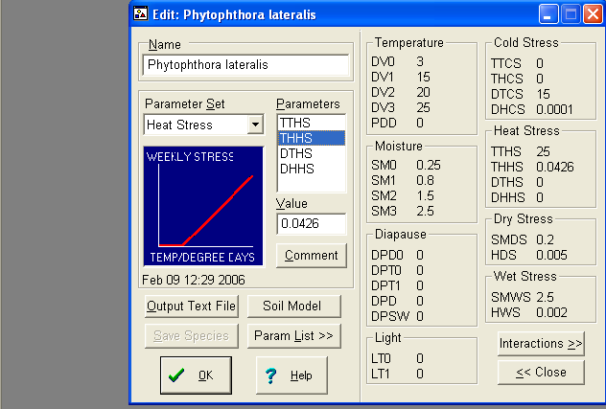

CLIMEX Compare location function for P. lateralis for the world (with Version 2)
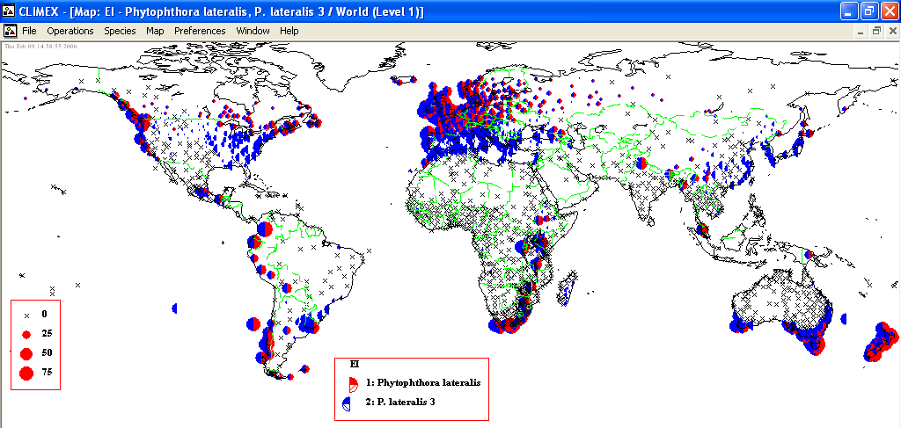

1: in red: P. lateralis with heat stress index re-calculated
2: in blue: P. lateralis with “Template Temperate” stress indexes.

The potential geographical distribution with re-calculated heat stress index is narrower than with the Template Temperate Heat stress.
Major effect is from heat stress in Eastern USA, Mediterranean Basin and China due to too high temperatures.

CLIMEX Compare location function for P. lateralis for the EPPO Region
(With version 2)
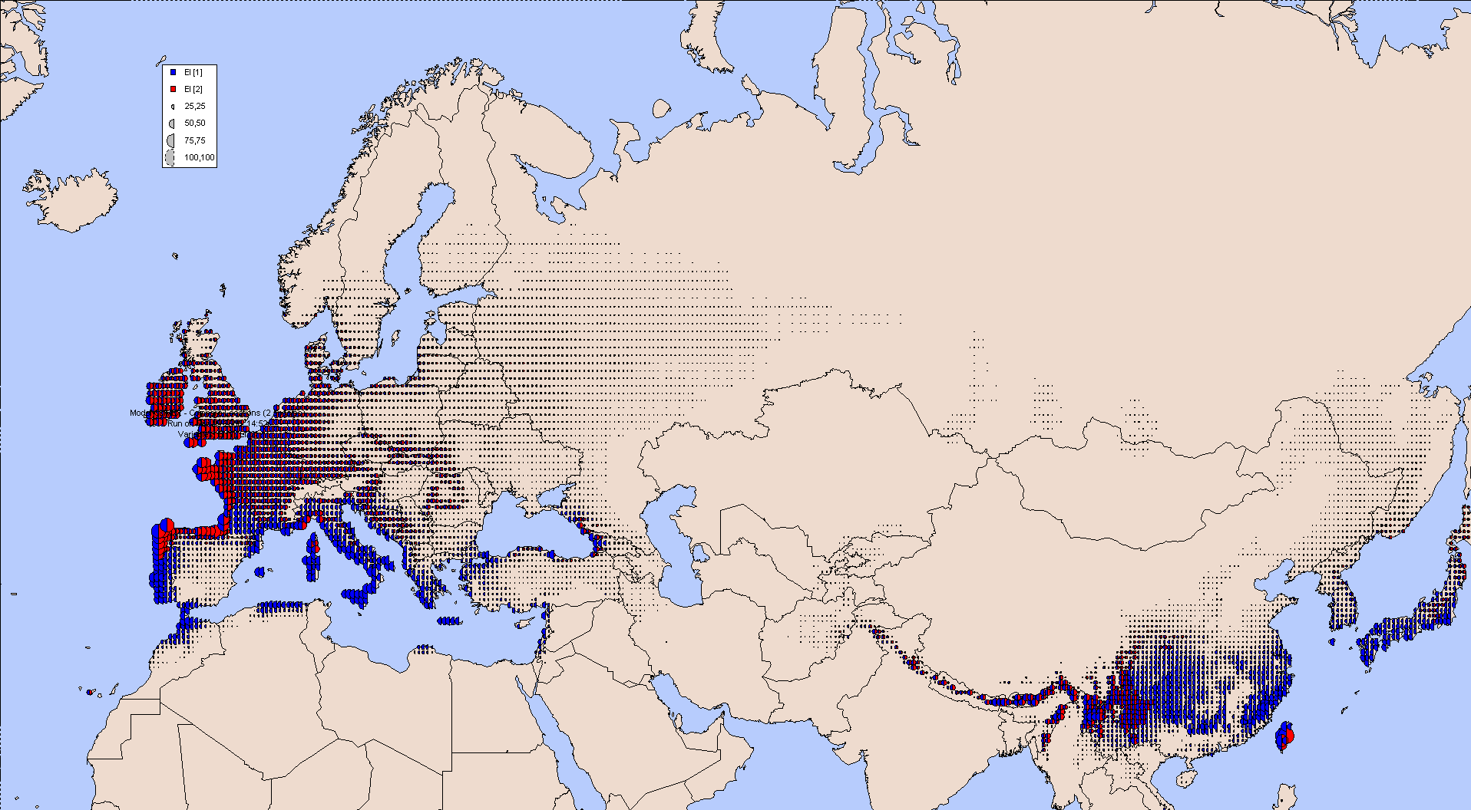

(With version 1)
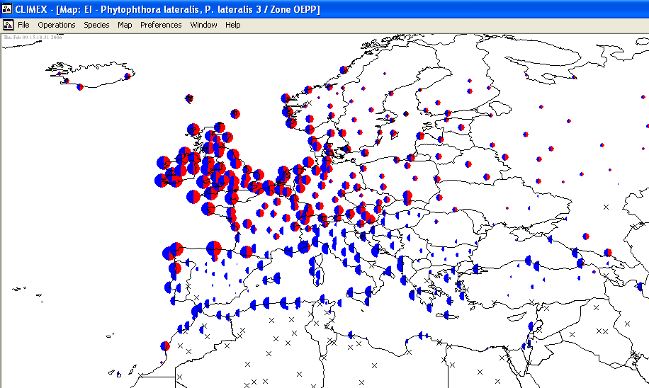

1: in red: P. lateralis with heat stress index re-calculated
2: in blue: P. lateralis with “Template Temperate” stress indexes.

The first map is based on gridded (interpolated data from CLIMEX), the second one is based on station data. The 2 maps show different results.
In the first one, North of UK, Norway, Sweden and Denmark are not considered suitable for the establishment of the species, while they are in the second map.

Match climate for the World with Vancouver
The following map shows the similar climatic conditions of Vancouver with the rest of the world with a similarity in climate >50%. Vancouver is the localisation allowing the largest range of similar climates in respect with the two other cities. Eureka has a climate similarity of 62% with Vancouver.

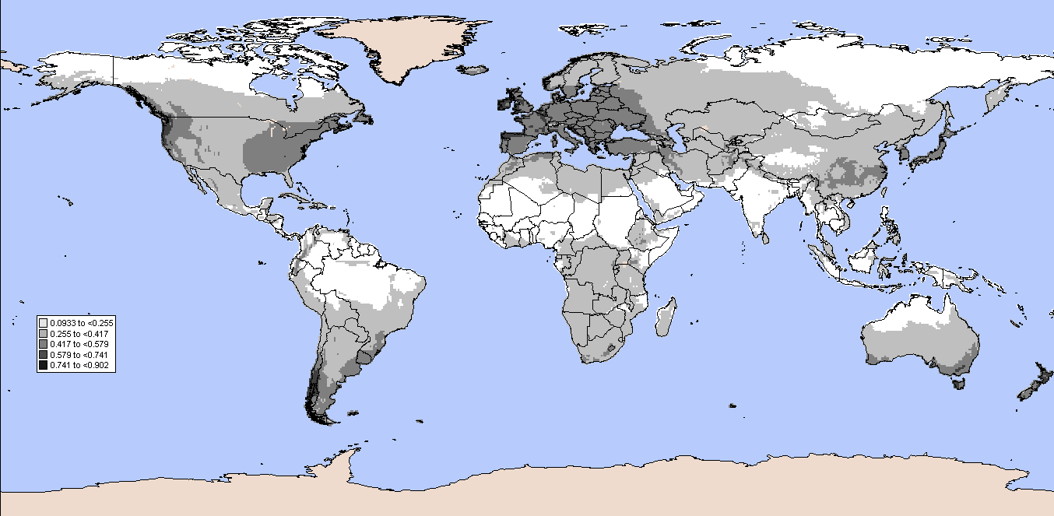

Match climate for the World with Eureka
The following map shows the similar climatic conditions of Vancouver with the rest of the world with a similarity in climate >50%.

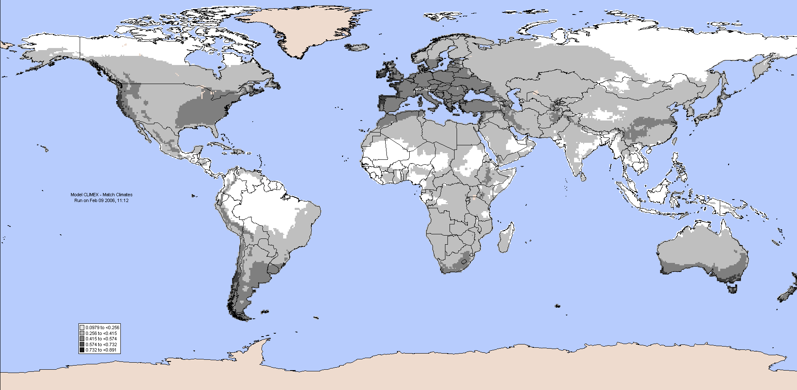

The climatic similarity with Eureka adds the following records to the map:
- Tanzania (Igeri, Sao Hill, Kabale)
- France ( La Rochelle, Toulon, Rennes)
- Bosnia-Herzegovina (Split)
- Greece (Vathi (Samos))
- Portugal (Coimbra, Evora, Lisbon)
- Morocco (Tanger)
- Italy (Firenze)
- Republic of Ireland (Dublin)
- Norway (Kristiansund)
- Turkey (Samsun, Sinop, Durres)
- United Kingdom (Tynemouth, Wick)
- Canada: Nova Scotia (Mount Wilson)
- Australia: Tasmania (Bicheno, Flinders Island, Redpa, St Helens, Lanceston), Victoria (Ararat, Warrnambool, Cann River, Casterton, Colac, Hamilton, Heywood, Warragu)), Western Wanganui),
- USA: California (San Francisco)
- New Zealand (Blenheim, Christchurch, Napier, Wanganui)
- Colombia (Bogota)
- …

Match climate for the EPPO region with Vancouver
The following map shows the similar climatic conditions of Vancouver with the EPPO region with a similarity in climate >50%:

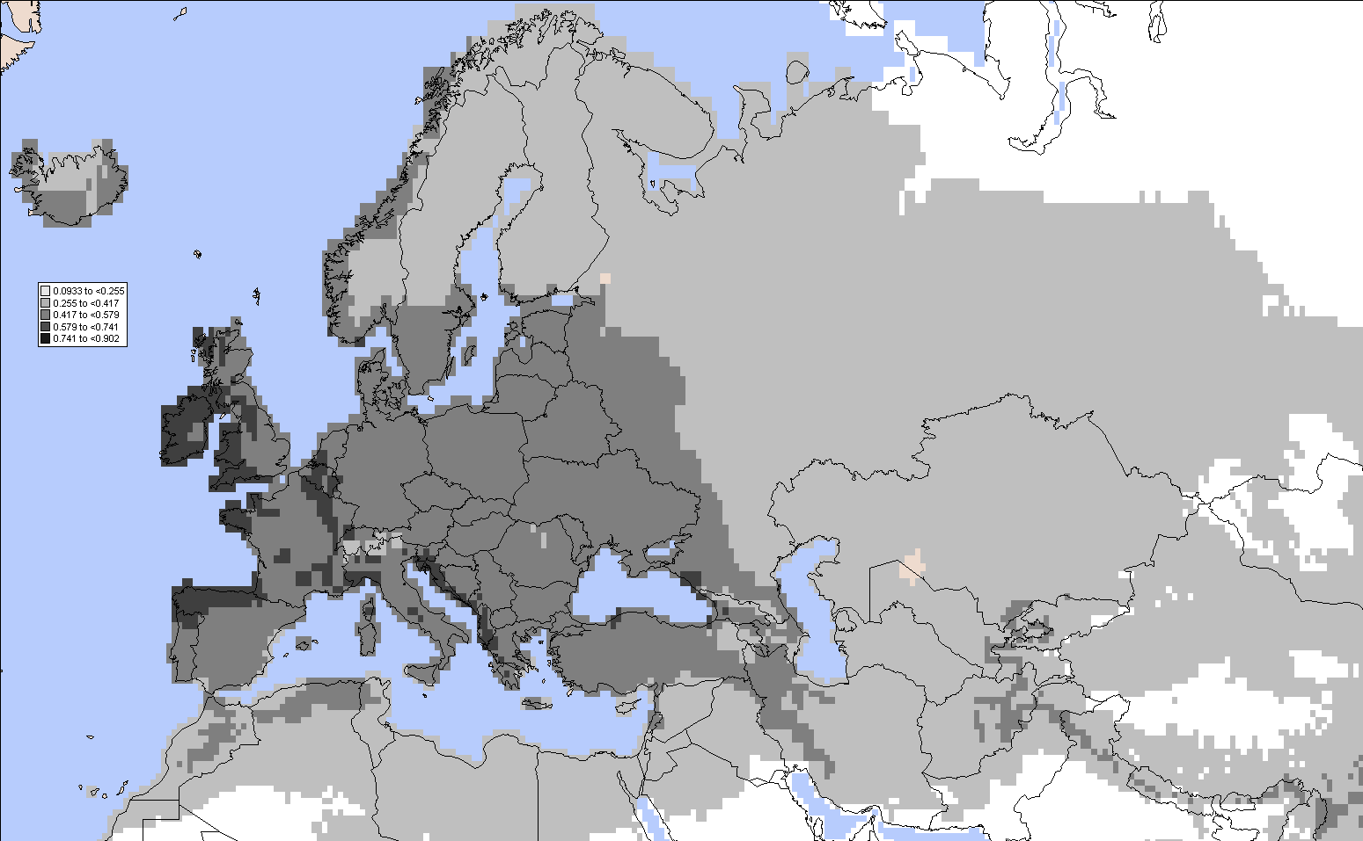

The coastal area appears to be very susceptible to the establishment of P. lateralis.

Match climate for the EPPO region with Vancouver
The following map shows the similar climatic conditions of Eureka with the EPPO region with a similarity in climate >50%:

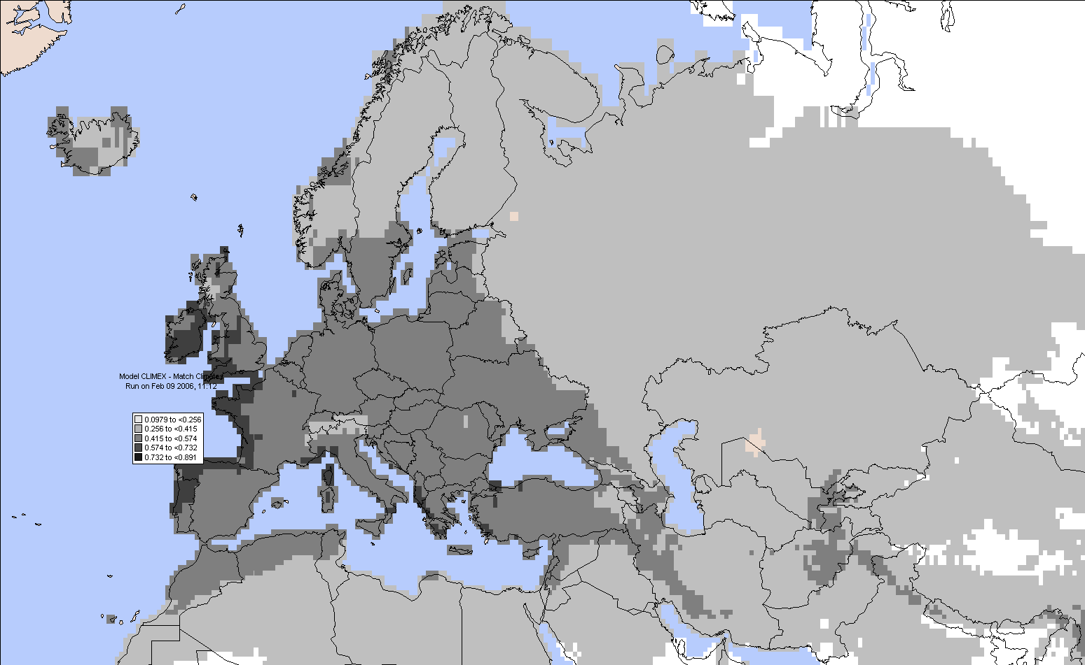

The most suitable locations are (Ecoclimatic Index >65):
- Republic or Ireland: Valencia (Considering Vancouver), Cork (Considering Eureka)
- Spain: La Corunia (Considering Eureka)
- United Kingdom: Plymouth and St Ann’s head (Considering Eureka) and Rayader??? - WHERE IS THIS – is this Rhayader in North Wales? (Considering Vancouver).

The CLIMEX options of “greenhouse effect” and “irrigation” have not been tested.

Conclusion

At this stage of knowledge of the geographical distribution of the pest responses to climate, we conclude it is more informative to use a climate match comparison with the locations of Vancouver and Eureka, where the species is established.

APPENDIX 2 REFERENCES CITED IN THE PRA

Abad ZG, Creswell T, Jones RK, Shew HD, 1994. Occurrence of Phytophthora species on various hosts in North Carolina. Plant Disease 78, 830.
Anon., 2000 (as amended). Council Directive 2000/29/EC of 8 May 2000 on protective measures against the introduction into the Community of organisms harmful to plants or plant products and against their spread within the Community. Official Journal of the European Communities 43 no. L 169, 1-143 (2004 unofficial consolidation).
CABI, 2006. Forestry Compendium [http://www.cabi.org/compendia/fc/].
DeNitto GA, Kliejunas JT, 1991. First Report of Phytophthora lateralis on Pacific Yew. Plant Disease 75, 968.
Erwin DC, Ribeiro OK, 1996. Phytophthora lateralis. In Phytophthora diseases worldwide. American Phytopathological Society, St Paul, 365-367.
Farr DF, Rossman AY, Palm ME & McCray EB (n.d.) Fungal Databases, Systematic Botany & Mycology Laboratory, ARS, USDA. Retrieved February 13, 2006, from http://nt.ars-grin.gov/fungaldatabases/
Gadgil PD, 2005. Fungi on trees and shrubs in New Zealand. Fungi of New Zealand Volume 4. Fungal Diversity Press, Hong Kong, 437 pages.
Hall G. Phytophthora lateralis. IMI Descriptions of Fungi and Bacteria No. 1065. 1991.
Hansen EM, 1985. Forest Pathogens of North West North America and their potential for damage in Britain. Forest Record 129, Forestry Commission, UK.
Hansen EM, Hamm PB, 1996. Survival of Phytophthora lateralis in infected roots of Port Orford Cedar. Plant Disease 80, 1075-1078.
Hansen EM, Steito JC, Delatour C, 1999. First confirmation of Phytophthora lateralis in Europe. Plant Disease 83, 587.
Hansen EM, Goheen DJ, Jules ES, Ullian B, 2000. Managing Port-Orford-Cedar and the introduced pathogen Phytophthora lateralis. Plant Disease 84, 4-14.
Hoitink HA, Schmitthenner AF, 1974. Relative prevalence and virulence of Phytophthora species involved in Rhododendron root rot. Phytopathology 64, 1371-1374.
Kliejunas JT, Adams DH, 1981. Phytophthora root rot of Port-Orford-cedar in California. Plant Disease 65, 446-447.
Meffert J, 2005. First record of Phytophthora lateralis in the Netherlands. Presentation at the UK Phytodiagnosticians meeting, 10th March, 2005. Royal Botanic Gardens Kew.
Murray MS, Hansen EM, 1997. Susceptibility of pacific yew to Phytophthora lateralis. Plant Disease 81, 1400-1404.
Pennycook SR, 1989. Part II. Fungal plant diseases recorded in New Zealand. Plant Diseases Recorded in New Zealand 2,5-502 Auckland: Plant Diseases Division, DSIR.
Roth LF, Harvey RD and Kliejunas JT, 1987 Port-Orford-Cedar Root Disease leaflet, USDA forest service website http://www.na.fs.fed.us/spfo/pubs/fidltabl.htm
Robertson GI, 1982. Kiwifruit can tolerate Phytophthora, but not ‘wet feet’. Orchardist of New Zealand 55, 148-151.
Tucker CM, Milbrath JA, 1942. Root rot of Chamaecyparis caused by a species of Phytophthora. Mycologia 34, 94-101.
Utkhede R, Stephen W, Wong S, 1997. Control of Phytophthora lateralis root rot of Lawson cypress with Enterobacter aerogenes. Journal of Arboriculture 23, 144-146.
Zobel DB, Roth LF, and Hawk GM, 1985. Ecology, Pathology, and Management of Port-Orford-Cedar (Chamaecyparis lawsoniana). United States Department of Agriculture Forest Service. Pacific Northwest, General Technical Report, PNW-184.

