EUROPEAN AND MEDITERRANEAN PLANT PROTECTION ORGANIZATION
ORGANISATION EUROPEENNE ET MEDITERRANEENNE
POUR LA PROTECTION DES PLANTES
06-12731 (06-12632, 06-12558)

Report of a Pest Risk Analysis Phytophtora lateralis

This summary presents the main features of a Pest Risk Analysis which has been conducted on Phytophtora lateralis, according to the EPPO Decision Support Scheme.

Pest: | Phytophthora lateralis Tucker & Milbrath
PRA area: | EPPO Region
Assessors: | Panel for PRA on P. lateralis :  Mrs Hella Kehlenbeck (DE, expert in socio economics), Mrs Irena Lielmane (LV, expert in risk management and member of the Panel on tools for PRA), Mrs Claire Sansford (GB, expert in the EPPO Decision support scheme and coordinator of the UK PRA on P. lateralis), Mrs Nathalie Schenck (FR, expert on Phytophthora), Mrs Joan Webber (GB, forestry expert and expert on Phytophthora), Mr Johan Meffert (NL, expert on Phytophthora sp), Mr Trond Rafoss (NO, expert in CLIMEX and the EPPO Decision support scheme).
Date: | 2006-02-16
Reviewed: | Panel on Phytosanitary Measures 2006-03-08.  Email consultation of the Panel PRA on P. lateralis 2006-04
STAGE 1: INITIATION

Reason for doing PRA: | Identification of a single pest that may a pose a risk to the EPPO region.
Taxonomic position of pest: | Kingdom-Chromista, Phylum-Oomycota, Order-Pythiales, Family-Pythiaceae, Genus-Phytophthora
STAGE 2: PEST RISK ASSESSMENT

Probability of introduction
Entry

Geographical distribution: | The pest is not known to be present in the EPPO region. Outbreaks have been declared in France (two outbreaks from a single origin) and the Netherlands but these are considered eradicated.  It is only recorded in North-Western USA and Canada.  Its origin is unknown.
Major host plants or habitats: | The most important hosts are Chamaecyparis spp.  Reports suggest they are only susceptible under specific conditions. Taxus brevifolia is an occasional host.  According to Hansen (E. Hansen, Oregon, USA, 2006, personal communication) published reports on hosts other than cedars (C. lawsoniana or Chamaecyparis spp.) and T. brevifolia are considered to be misidentifications.  Whilst not considered further in this analysis the first reports of these are:  Actinidia chinensis (Robertson, 1982); Actinidia deliciosa (Pennycook, 1989; Gadgil, 2005); Catharanthus roseus (Abad et al., 1994); Juniperus horizontalis (Abad et al., 1994); Kalmia latifolia (Abad et al., 1994); Photinia x fraseri (Abad et al., 1994); Rhododendron sp. (Hoitink and Schmitthenner, 1974); Rhododendron sp. (azalea) (Abad et al., 1994); Platycladus orientalis (syn. Thuja orientalis) Hall, 1991.
Which pathway(s) is the pest likely to be introduced on: | Taking the affected areas of North America as the start of each pathway:  - Plants for planting of Chamaecyparis spp. (as cuttings or as plants with growing media attached) from USA and Canada  - Plants for plating of Taxus brevifolia (as cuttings or as plants with growing media attached) from USA and Canada  - Plants for planting of non host plants with growing media attached from USA and Canada (on growing media)  - Soil/growing medium (with organic matter) from USA and Canada as a commodity  - Soil from USA and Canada as a contaminant (on machinery, footwear).
Establishment

Plants at risk in the PRA area: | Chamaecyparis spp. (C. formosensis, CABI, 2005; C. lawsoniana, Tucker & Milbrath, 1942; C. obtusa, Tucker & Milbrath, 1942),  Taxus brevifolia, DeNitto & Kliejunas, 1991.
Climatic similarity of present distribution with PRA area (or parts thereof): | The following conclusions were made solely on the basis of the match-climate routine using CLIMEX (similarities in climate superior to 50%). The whole of the PRA area is not completely similar to the area of current distribution. The following countries of the EPPO region, have similarity in climate superior to 50% particularly in coastal areas: Albania, Algeria, Austria, Azerbaijan, Belgium, Bosnia-Herzegovina, Croatia, Denmark, France, Georgia, Greece, Italy, the Netherlands, Norway, Portugal, Republic of Ireland, Spain, Turkey, United Kingdom (see Appendix 2)  The Panel considered that the climatic conditions that would affect pest establishment are moderately similar in the PRA area.
Aspects of the pest's biology that would favour establishment: | Competition with other species is very unlikely to limit its establishment and no enemies are known.  The species is favoured by nursery production practices (irrigation, high levels of fertilisers etc).  The pathogen has long lived resilient chlamydospores and oospores.  Under favourable conditions, production of the infective spores (sporangia) may occur very rapidly.  The pathogen is adaptable because it can withstand climatic extremes. However, it does not have many host species and its populations have low genetic diversity because of its sexual reproduction strategy.
Characteristics (other than climatic) of the PRA area that would favour establishment: | The host plants are widely distributed in the PRA area as cultivated ornamental plants, except in Siberia. These species even occur in the wild in the western part of Europe.  No treatments are effective at eradicating the pest and the species is difficult to detect through symptoms alone which may be confused with symptoms caused by other Phytophthora species.  Abiotic factors that could affect establishment in the PRA area are moderately similar to those in the current distribution area of the pest.
Which part of the PRA area is the endangered area: | The Panel considered that the endangered area (based only upon climatic conditions and not related to the biology of the pathogen) is composed of the following countries of the EPPO region particularly their coastal areas: Albania, Algeria, Austria, Azerbaijan, Belgium, Bosnia-Herzegovina, Croatia, Denmark, France, Georgia, Greece, Italy, the Netherlands, Norway, Portugal, Republic of Ireland, Spain, Turkey, United Kingdom.  Nurseries in general are at risk because of production practices.
POTENTIAL ECONOMIC CONSEQUENCES
How much economic impact does the pest have in its present distribution: | P. lateralis is thought to have nearly destroyed the multi-million dollar ornamental cedar (C. lawsoniana) industry in northwest Oregon and western Washington (Hansen et al., 2000). Affected land cannot be used to produce Chamaecyparis.  The Panel considered that within its current area of distribution, the pest has a massive effect on yield and quality and a major effect on control costs for cultivated plants. Social damage arising from loss of income is major. Environmental damage is considered to be massive. Social damage arising from loss of fishing and tourism because of forest closures is major..
Describe damage to potential hosts in the PRA area: | The pest is likely to mainly affect yield and quality of host plants grown in nurseries.
How much economic impact would the pest have in the PRA area: | The Panel considered that the pathogen would have a massive effect on crop yield and/or quality in the PRA area. Increase in production costs including control costs is likely to be major. Loss of export markets may occur but there is uncertainty because it is not known which of the host plants are exported from the EPPO region.
CONCLUSIONS OF PEST RISK ASSESSMENT
Summarize the major factors that influence the acceptability of the risk from this pest: | - Outbreaks related to plants introduced with infested soil are reported  - It is very likely that the pest will survive or remain undetected during existing phytosanitary measures, moreover, P. lateralis symptoms expression may be suppressed by fungicide treatment.  - The pest is established in an area with similar climatic conditions to some parts of the PRA area and causes serious economic damage in its area of establishment (where it is considered to be an exotic introduction).  - It has a reproductive strategy likely to help introduction (two long lived spore stages, chlamydospores and oospores)  - The species is favoured by nursery practices (irrigation, high levels of fertilisers etc.).
Estimate the probability of entry: | The probability of entry is considered as medium mainly because the importation of the main hosts is assumed to be limited. The following pathways originate in affected areas of North America or Canada:  1. Plants for planting of Chamaecyparis spp. (as cuttings or plants with growing medium attached): highest risk  2. Plants for planting of Taxus brevifolia (as cuttings or plants with growing medium attached): medium risk  3. Plants for planting of non host plants with growing medium attached: low to medium risk  4. Soil as a commodity: low to medium risk  5. Soil as a contaminant on machinery: low to medium risk  6. Soil as a contaminant on footwear: low risk
Estimate the probability of establishment: | The probability of establishment is high (host plants are cultivated in the PRA area, some parts of the PRA area have very favourable climatic conditions, nursery production practices are favourable to the pathogen).
Estimate the potential economic impact: | Economic importance would be high in particular for nurseries. Economic impacts would mainly arise from losses of host plants on specialist nurseries (but there is few data available on the importance of specialised nurseries in the EPPO region apart from UK). Environmental impacts are thought likely to be low because the main hosts are not key components of natural ecosystems in the PRA area
Degree of uncertainty | The following areas have varying degrees of uncertainty:  - Volume of trade of susceptible ornamental plants.  - Control in the nurseries in the USA and Canada.  - Spread in soil by people and its relationship to the probability of introduction and spread.  - Source of the original infestation, whether it was introduced to North America on other unknown hosts.  - Distribution of existing hosts within the PRA area and if specialised nursery exist in countries other than the UK and to what extent.  - Export markets for the natural hosts from the EPPO region  - Why the pathogen only affects its hosts in a localised area of north-west USA and south-west Canada  - Susceptibility of other important ornamental and tree species  - Potential of P. lateralis to hybridise with other Phytophthora species.  - - The genetic status of the strains of the outbreaks in France and the Netherlands need to compared with the US strains.  - Where did the pest come from (origin)?
OVERALL CONCLUSIONS | The pest fulfils the criteria of a quarantine pest. There is a risk of entry, establishment and economic impact. The Panel considers that the risk from the pest is not acceptable.

Stage 3: PEST RISK MANAGEMENT
-

IDENTIFICATION OF THE PATHWAYS

Pathways studied in the pest risk management

Taking the affected areas of North America and Canada as the start of each pathway:
Pathway 1 and 2: Plants for planting of Chamaecyparis spp., and Taxus brevifolia (cuttings or plants with growing medium attached) from the USA and Canada
Pathway 3: Plants for planting of non-host plants with growing medium attached from the USA and Canada
Pathway 4: Soil/growing medium (with organic matters) as a commodity from the USA and Canada

Pathway 5: Soil as a contaminant on machinery from the USA and Canada
Pathway 6: Soil as a contaminant on footwear from the USA and Canada

Other pathways identified but not studied | None

IDENTIFICation of POSSIBLE measures
Pathway 1 and 2: Plants for planting of Chamaecyparis spp., and Taxus brevifolia (cuttings or plants with growing medium attached) from the affected parts of the USA and Canada
The Panel decided to consider all host plants together in the pest risk management stage (risk presented and evaluated to be medium to high)

Measures related to consignments:
Testing of plants and growing medium is feasible but will not detect low levels of infestation and is not practicable

Measures related to the crop or to places of production:
As the pest is considered to have a medium mobility, pest-free place of production and buffer zone or pest-free place of production and exclusion measures for running water for P. lateralis or pest-free area for P. lateralis are recommended measures.

Other possible measures
No internal measures such as surveillance and/or eradication campaign have been identified

Pathway 3: Plants for planting of non-host plants with growing medium attached from the affected parts of the USA and Canada
Measures related to consignments:
Although testing of growing media is possible, it is not practical.

Measures related to the crop or to places of production:
As the pest is considered to have a medium mobility, pest-free place of production for P. lateralis and buffer zone, or pest-free place of production and exclusion measures for running water, or
pest-free area for P. lateralis are recommended measures.
Note: The establishment of a pest-free place of production (including the need and extend of the buffer zone) for P. lateralis in an area where the pest is present depends on topography, water courses, existence of hosts in the buffer zone, inspection and testing at the place of production and the possibility of implementing exclusion measures for water courses.

Other possible measures
No internal measures such as surveillance and/or eradication campaign have been identified

Pathway 4: Soil/Growing medium (with organic matters) as a commodity from the affected parts of the USA or Canada
Measures related to consignments:

Heat treatment or sterilisation of the soil is a recommended measure
Testing of growing medium is feasible but may not detect low levels of infestation and is not practicable.

Measures related to the crop or to places of production:
As the pest is considered to have a medium mobility, pest-free place of production for P. lateralis or
pest-free area for P. lateralis are recommended measures. This means that the soil or growing medium has to be collected in a pest-free place of production or a pest-free area.

Other possible measures
No internal measures such as surveillance and/or eradication campaign have been identified

Pathway 5: Soil as a contaminant on machinery from the affected parts of the USA or Canada
Cleaning or disinfection of imported machinery or vehicles is recommended.

Pathway 6: Soil as contaminant on footwear from the affected parts of the USA or Canada
Publicity to enhance public awareness on pest risks is a recommended measure.

EVALUATION OF THE MEASURES IDENTIFIED IN RELATION TO THE RISKS PRESENTED BY THE PATHWAYS
The risks presented by the pathways have been ranked from low to high. The pathways on which the Panel is recommending specific phytosanitary measures are plants for planting of host plants of the pest, plants for planting of non-host plants with growing medium attached and soil/growing media as a commodity. Similar measures are recommended for these commodities.
General measures are recommended for used machineries and travellers.

Degree of uncertainty | Importance of pathways such as used machinery or human travellers is not well known.

CONCLUSION:

Recommendation for possible measures for the endangered area:

Plants for planting of Chamaecyparis spp. and Taxus brevifolia originating in countries where Phytophthora lateralis occurs | PC and, if appropriate, RC  Area freedom for Phytophthora lateralis according to EPPO Phytosanitary Procedure No  or  Place of production freedom and appropriate buffer zone for Phytophthora lateralis.  or  pest-free place of production and exclusion measures for running water
Plants for planting of non host plants with growing medium attached originating in countries where Phytophthora lateralis occurs | PC and, if appropriate, RC  Area freedom for Phytophthora lateralis according to EPPO Phytosanitary Procedure No  or  Place of production freedom and appropriate buffer zone for Phytophthora lateralis  Or  Pest-free place of production and exclusion measures for running water,
Soil and growing medium (with organic matters) originating in countries where Phytophthora lateralis occurs | PC and, if appropriate, RC  Heat treatment or soil sterilisation  or  Area freedom for Phytophthora lateralis according to EPPO Phytosanitary Procedure No  or  Place of production freedom and appropriate buffer zone for Phytophthora lateralis 4  Or  Pest-free place of production and exclusion measures for running water,
Used machinery originating in countries where Phytophthora lateralis occurs | Cleaning or disinfection of imported machinery or vehicles
Footwear from countries where Phytophthora lateralis occurs | Publicity to enhance public awareness on pest risks

PC= Phytosanitary Certificate, RC= Phytosanitary Certificate for Re-Export

Appendix 1
For each possible category of measures in the pest risk management scheme, this table identifies specifically the ones which were considered suitable ("possible" in bold) and the ones which were not suitable

categories of MeasureS | Pathway n° 1 and 2 | Pathway n° 3 | Pathway n° 4 | Pathway n° 5 | Pathway n° 6
Detection of the pest in consignments by inspection or testing
visual inspection | no | no | no
specified testing | yes | yes | yes
import under special licence/permit and post-entry quarantine | no | no | no
Removal of the pest from the consignment by treatment or other phytosanitary procedures
specified treatment | no | no | yes
removal of parts of plants from the consignment | no | no | no
Prevention of establishment by limiting the use of the consignment
import under special licence/permit and specified restrictions | no | no | no
Prevention of infestation of the commodity
specified treatment and/or period of treatment (crop) | no | no | no
consignment should be composed of specified cultivars | no | no | no
specified protected cultivation | no | no | no
specified age of plant, growth stage or time of year of harvest | no | no | no
specific handling/packing methods | no | no | no
certification scheme | no | no | no
Establishment and maintenance of pest freedom of a crop, place of production or area
pest freedom of the crop | no | no | no
pest-free place of production | no | no | no
pest-free place of production and appropriate buffer zone | yes | yes | yes
pest-free area | yes | yes | yes
Prohibition | no | no | no
Internal measures
surveillance and/or eradication campaign | no | no | no
Cleaning or disinfection of imported machinery or vehicles |  |  |  | yes
Publicity to enhance public awareness on pest risks |  |  |  |  | yes
Inspection of travellers |  |  |  |  | no

APPENDIX 2

Potential Geographical Distribution of Phytophthora lateralis, with emphasis on the EPPO region

CLIMEX is a computer programme aiming at predicting the potential geographical distribution of an organism considering its climatic requirements. It is based on the hypothesis that climate is an essential factor for the establishment of a species in a country. In order to predict the potential geographical distribution of P. lateralis in the EPPO region, the “match climate” function of CLIMEX was used. A comparison was made between locations where P. lateralis is known to be present ( Eureka, US California and Vancouver, CA), and the EPPO region. This document present the results of this analysis.

Match climate for the EPPO region with Vancouver

The map shows the part of the EPPO region with a similarity in climate>50% compared to Vancouver:

Coastal areas appear to be favourable for the establishment of P. lateralis.
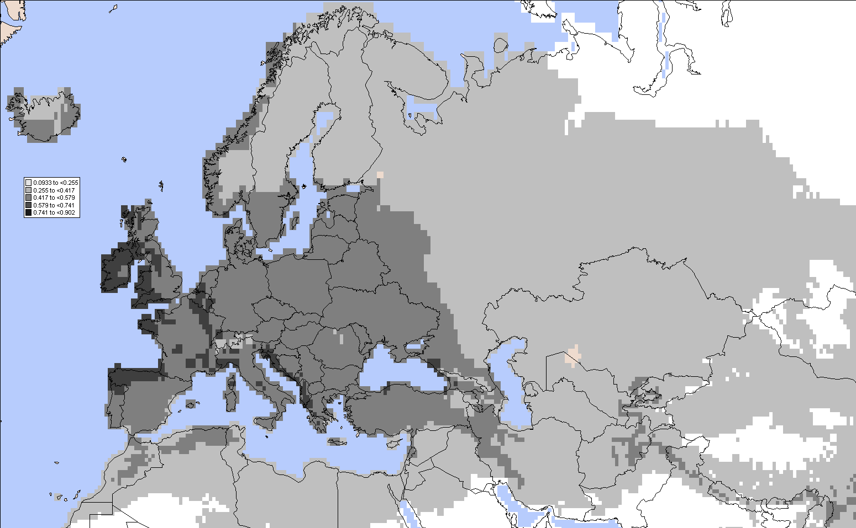

Match climate for the EPPO region with Eureka

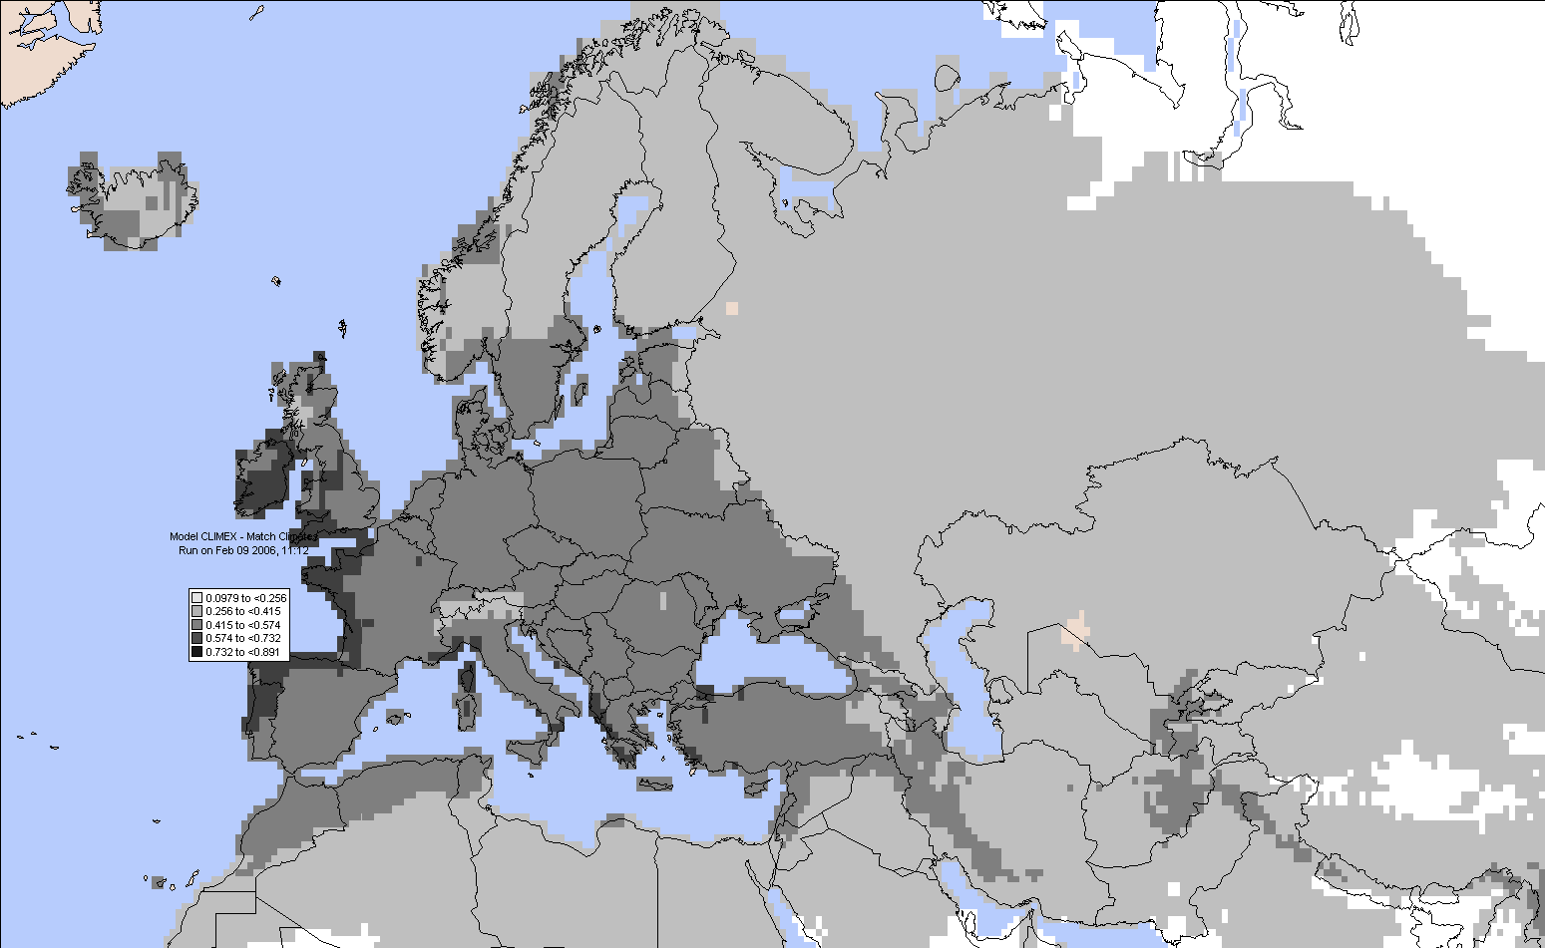

The map shows the part of the EPPO region with a similarity in climate >50% compared to Eureka.

The most suitable locations (Ecoclimatic Index >65) are:
Republic or Ireland: Valencia (when compared to Vancouver), Cork (when compared to Eureka)

Spain: La Corunia (when compared to Eureka)
United Kingdom: Plymouth and St Ann’s head (when compared to Eureka) and Rhayader (when compared to Vancouver).

According to ISPM 10 "Requirements for the establishment of pest-free places of production and pest-free production sites"
According to ISPM 4 " Requirements for the establishment of pest-free areas".
4
the soil or growing medium should be collected in a pest-free place of production or a pest-free area.

